ANALYSIS OF THE EFFECT OF NITROGEN IN SYNTHESIS OF DIAMOND-LIKE FILMS WITH DIFFERENT METHODS OF GAS ACTIVATION *)
DOI: 10.34854/ICPAF.2021.48.1.133
¹Medvedev A.E., ²Emelyanov A.A., ²Yudin I.B., ²Plotnikov M.Yu., ²Timoshenko N.I. and ³Okotrub A.V.
¹Institute of Laser Physics SB RAS, medvedev@laser.nsc.ru
²Institute of Thermophysics SB RAS, alemelyanov@gmail.com
³Institute of Inorganic Chemistry SB RAS, spectrum@niic.nsc.ru
In this paper, the effect of nitrogen additions on the synthesis of diamond films with various methods of precursor activation is analyzed: 1) in a microwave plasma at a flow of gases at moderate pressures; 2) in a microwave chamber at low pressure [1]; and 3) in a flow of gases activated by a heated tungsten filament [2].
Nitrogen additions are of interest, because there appear vacancies at nitrogen additions [3] which, at a concentration of more than 0.1%, are of particular importance for thermodynamic stabilization of the structure with respect to the diamond-graphite transition [4], providing CVD growth of diamond in a metastable state. Nitrogen is also the most suitable candidate for the role of a doping agent in obtaining electronic impurity conductivity with a deep donor energy level (of about 1.7 eV). When diamond is used as a low-dimensional system for quantum informatics, nitrogen-vacancy (NV) defects hold much promise. Finally, the addition of nitrogen to the gas mixture accelerates the growth of {100} faces with respect to {111} up to 4 times [5], which allows controlling the structure of diamond crystals in the process of gas-phase chemical deposition.

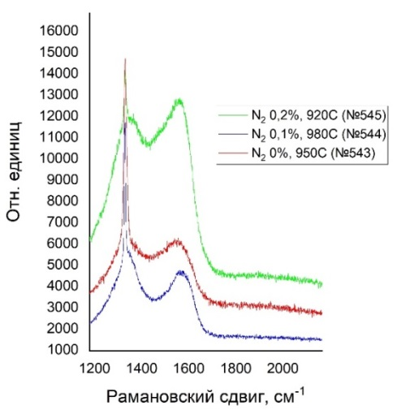

Fig. 1. SEM images: a) sample no. 543 (without nitrogen);
b) sample no. 544 (with the addition of 0.1% nitrogen).

Fig. 2. Raman spectrum of a diamond-like film obtained with activation of a gas mixture by a heated tungsten filament.

The results of measuring the Raman spectrum show that the optimal content of nitrogen in the mixture is not more than 0.1%. Nitrogen addition narrows the diamond line near 1333 cm⁻¹ (in our case from 20 cm⁻¹ to 7 cm⁻¹). The character of the G-line indicates that the graphite that is present is in a highly disordered (soot-like) state. Higher ordering of crystals with the addition of nitrogen is also confirmed by SEM images.
This work was supported by the Russian Foundation for Basic Research (no. 18-29-19069 MK, no. 18-29-19130 MK and no. 19-08-00533) and under state assignment (AAAA-A17-117021750017-0).
References
- Polyakov O.V., Gorodetsky D.V., Okotrub A.V. Technical Physics Letters, 39 13 (2013).
- Emelyanov A.A., Plotnikov M.Yu., Yudin I.B. Technical Physics, 89 (2019) 1891.
- Davies G., Lawson S., Collins A., Mainwood A., Sharp S. Phyical Review, B, 46 (1992).
- Bar-Yam Y., Moustakas T.D. Nature, 342, 786 (1989).
- Yiming Z., Larsson F., Larsson K. Theoretical Chemistry Accounts, 133, 1432 (2014).

*) abstracts of this report in Russian

