Building of infrastructure for promising tokamaks with reactor technologies on the basis of JSC “SSC RF TRINITY” *)
DOI: 10.34854/ICPAF.2021.48.1.068
Rodionov N.B., Ilyin K.I., Romannikov A.N., Dryagin S.Yu.
JSC "SSC RF TRINITY", Troitsk, Moscow, Russia, rodionovnb@gmail.com
Works on scientific and technical justification of systems for the project of reconstruction of the TSP thermonuclear complex based on the Ignitor-type tokamak were provided. Technical requirements for systems have been developed:
- for energy and power supply;
- for vacuum;
- for magnetic;
- for water cooling;
- for cryogenic complex;
- for auxiliary heating and start-up diagnostics.
The elements of the tritium cycle were developed to provide the operation of the Ignitor-type tokamak under the conditions of tritium production in the DD reaction and possible modes with the introduction of controlled doses of tritium from gas injection systems (development of technological schemes and specifications, information on consumed resources, description of the technological process). An experimental justification of the detritization of technological gas flows of the tritium cycle was carried out. The theoretical and computational justification of the tritium breeding ratio and the production of nuclear fuel in the test -module blanket was carried out.
The results obtained in this work allows to create the infrastructure of a test complex for promising tokamaks with a large radius of about 2 m and their elements. The next steps within the reconstruction project will be the creation of design systems and specialized stands, the development of methods for experimental verification of systems and subsystems of the infrastructure that provides the functioning of tokamaks and participation in the implementation of draft and of design documentations.
The project, together with the T-15MD tokamak, will become the second research center for Russian fusion program, uniting the scientific and technical potential of Russian plasma physics teams, providing a wide range of research, and will also provide training for the operation of the ITER tokamak and future Russian tokamaks.

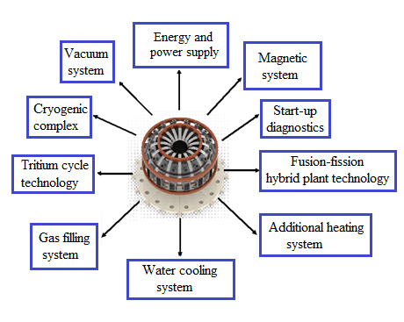
Figure 1. Infrastructure of the Ignitor-type tokamak

The work was carried out within the framework of the state contract N. Н.4с.241.09.20.1096 of 22 June 2020.

*) abstracts of this report in Russian

