High-voltage test bench for heavy ion beam probe diagnostics of t-15MD tokamak *)
DOI: 10.34854/ICPAF.2021.48.1.051
²Vadimov N.A., ¹Drabinskiy M.A., ^{2,3}Melnikov A.V., ²Sarancha G.A.
¹NRC “Kurchatov Institute”, Moscow, Russia, nrcki@nrcki.ru
²Moscow Institute of Physics and Technology, Moscow, Russia, info@mipt.ru
³National Research Nuclear University “MEPhI”, Moscow, Russia, info@mephi.ru
Heavy Ion Beam Probing (HIBP) is a unique method of potential measurements in hot regions of magnetically confined plasmas, i.e. tokamaks and stellarators. Aside from direct local measurements of plasma potential with high temporal resolution, HIBP also allows for simultaneous measurements of local electron density fluctuations and fluctuations of plasma current field [1]. HIBP was used for plasma diagnostics on T-10 tokamak and is actively used on TJ-II stellarator [2]. It is also a part of diagnostic complex of the largest tokamak in Russia, T-15MD (R = 1.5 m, a = 0.67 m, B_{t} = 2 T, I_{pl} = 2 MA), which is currently being prepared for commissioning [3]. Estimations show that probing beam path through T-15MD plasma will be as long as 1.0-1.5 m [4]. With high plasma densities this will lead to strong beam attenuation, therefore to operate HIBP with high beam attenuation, the beam intensity ≥200 mA and focus length ~3 m is required [5]. This work describes the design and operation principles of a test bench aimed at creation and testing of stationary high-intensity ion beams. The test bench allows to study the parameters of the ion-optics system and thermionic emitters, including beam intensity, its diameter, focal length and spatial distribution of current in the beam (fig. 1). In the future the test bench can be used for adjustment and calibration of the HIBP energy analyzer.
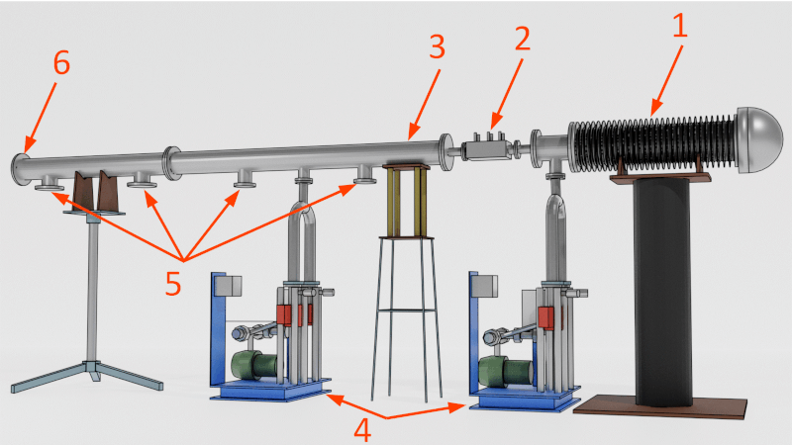
Fig. 1: Technical design of the high-voltage test bench: HIBP injector – 1; beamline – 2; beam flight tube – 3; vacuum pumping system – 4; ports for wire sensors – 5; Faraday cup – 6
References
- A.V. Melnikov et al. Heavy ion beam probing – diagnostics to study potential and turbulence in toroidal plasmas // Nucl. Fusion 2017, 57, 072004.
- A.V. Melnikov Electric Potential in Toroidal Plasmas // Springer Nature Switzerland AG 2019, 240 pp, ISBN 978-3-030-03480-1.
- A.V. Melnikov et al. Physical Program and Conceptual Design of the Diagnostics of the T-15 Upgrade Tokamak // Fusion Engineering and Design, 2015, 96–97, 306–310.
- M.A. Drabinskiy et al. Conceptual design of the heavy ion beam probe diagnostic for the T-15MD tokamak // J. Inst., 2019, 14 (11), C11027.
- N.A. Vadimov et al. The high voltage test bench for heavy ion beam probe diagnostics on the T-15MD tokamak // Probl. Atom. Sci. Techn. Ser. Plasma Physics, (26), 6 (130), 2020, 200-203

*) abstracts of this report in Russian

