COMPARISON OF HYDROGEN AND HELIUM DISCHARGE PARAMETERS IN GOLEM small TOKAMAK *)
DOI: 10.34854/ICPAF.2021.48.1.049
¹Sarancha G.A., ³Svoboda V., ^{3,4}Stöckel J., ^{2,4}Melnikov A.V.
¹NRC “Kurchatov Institute”, Moscow, Russia, nrcki@nrcki.ru
²NRU “Moscow Institute of Physics and Technology”, Moscow, Russia, info@mipt.ru
³Czech Technical University, Prague, Czech Republic, cvut@cvut.cz
⁴National Research Nuclear University “MEPhI”, Moscow, Russia, info@mephi.ru
For studying plasma with parameters approaching the future fusion reactor, the bigger devices for plasma magnetic confinement are under construction. It requires large financial and labor resources, and most importantly - time. It could happen when at the device starting there would not be any person designed it. Therefore, it is necessary to conduct new staff continual training. Small tokamaks [1], for example MEPhIST [2], Globus-M2 [3] or GOLEM [4], are best suited for this purpose.
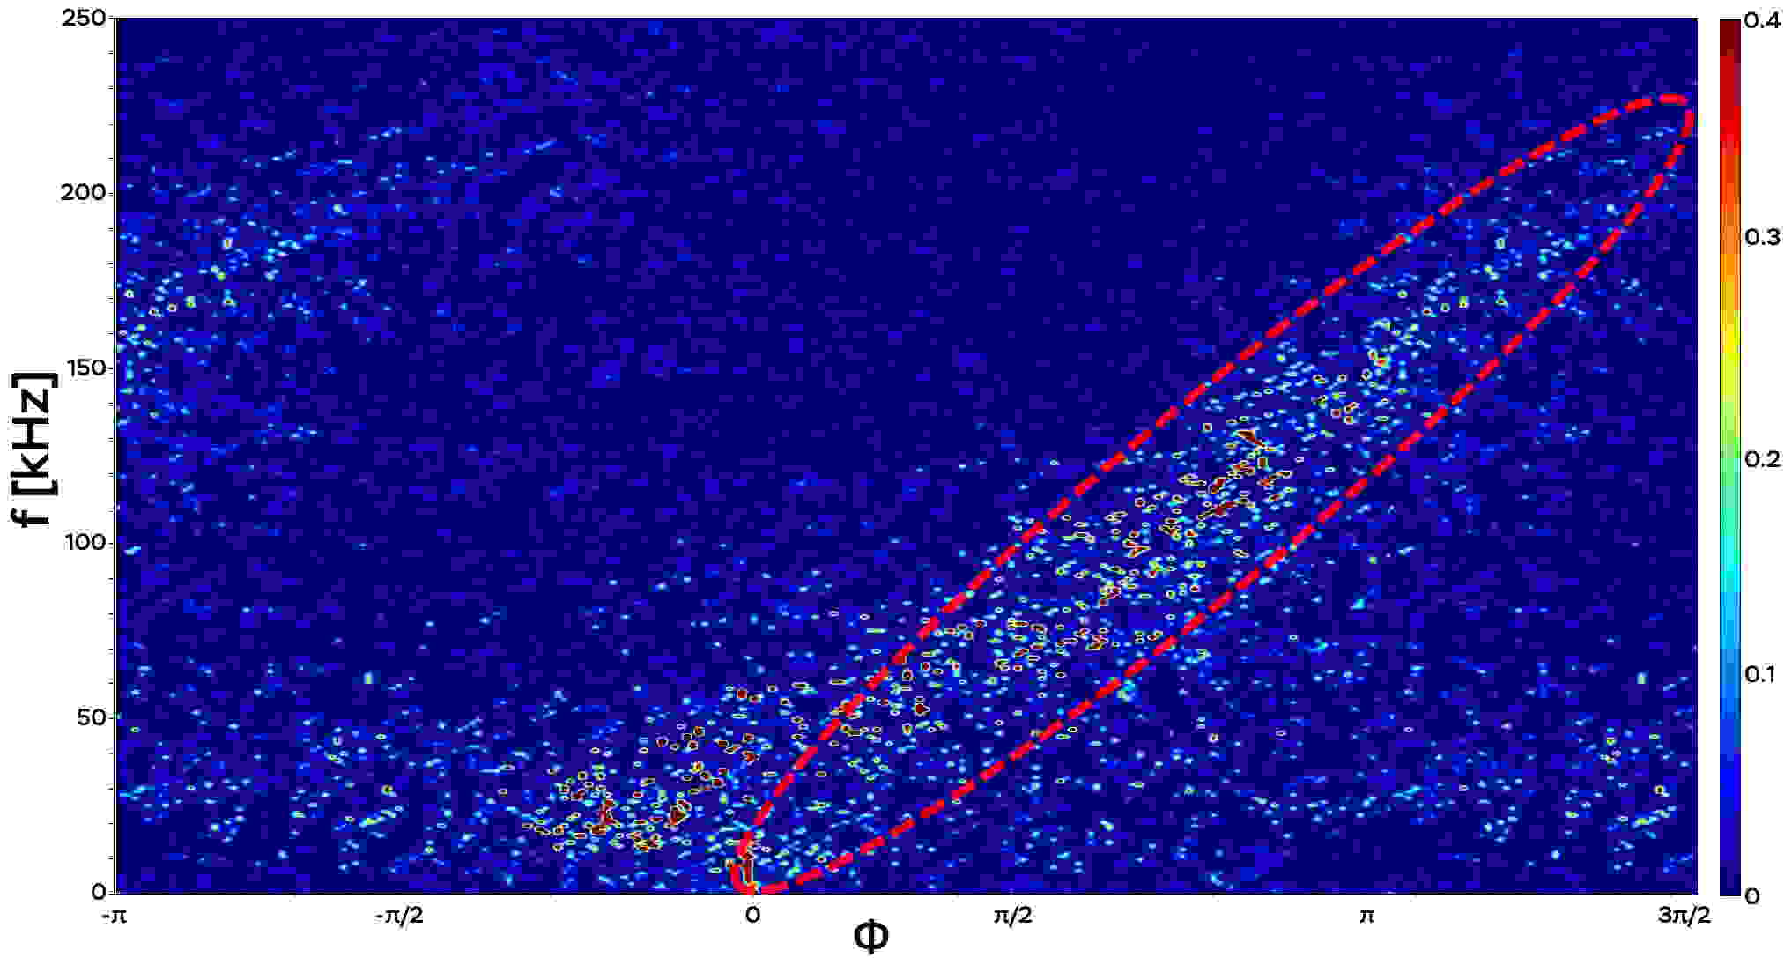 The report presents the results of remote experiments (using a virtual control room) conducted in May 2020 by students of NRNU MEPhI and NRU MIPT with the support of the Faculty of Technical and Nuclear Physics of the Czech Technical University at the GOLEM tokamak. Experiments have shown that the evolution of plasma in hydrogen and helium is very different, despite the same discharge parameters (gas pressure, plasma current, and magnetic field). The main parameters of the plasma discharge were studied (the relationship between the electron temperature and the plasma current; the duration of the discharge and the plasma current, etc.). The presence of long-range correlations between low-frequency (< 50 kHz) electrostatic and magnetic oscillations is shown, as well as the existence of broadband (< 250 kHz) magnetic oscillations resolvable in frequency f and wave vector k (fig. 1) in helium plasma.
Fig. 1 Two-dimensional spectrum S (k, f) of magnetic oscillations in a helium discharge
This work was supported by the Russian Science Foundation, project 19-12-00312.
References
- M.P. Gryaznevich et al, Contribution of Joint Experiments on Small Tokamaks in the framework of IAEA Coordinated Research Projects to mainstream Fusion Research // Plasma Sci. Technol., 2020, 22 055102
- V.A. Kurnaev et al. Development status of the MIFIST tokamak // Bulletin of the NRNU MEPhI, 2019, No. 6, pp. 491-497
- N.N. Bakharev et al. Results of the first experiments on the Globus-M2 tokamak // Plasma Physics, 2020, No. 7, pp. 579-587
- O. Grover et al. Remote operation of the GOLEM tokamak for Fusion Education // Fusion Eng. Des., 2016, 112, 1038–1044

*) abstracts of this report in Russian

