ELECTRON DISTRIBUTION FUNCTION IN THE CENTRAL REGION OF PLASMA IN THE PRESENCE OF AN EXTERNAL SOURCE (OH, ECRH) (ACCORDING TO RESULTS OF EXPERIMENTS AT THE T-10 TOKAMAK) *)
DOI: 10.34854/ICPAF.2021.48.1.047
Borschegovskiy A.A.
NRC “Kurchatov Institute”, 1, Akademika Kurchatova pl., Moscow, 123182, Russia, Borschegovsky@yandex.ru
The main part of experiments on ECR-heating of plasma, carried out at the T-10 tokamak in recent years was performed on the 2nd harmonic of the ECR in the X-mode with an oblique input from the side of weak magnetic field of focused microwave radiation at a toroidal angle of ~ 20°. The total input power from the two gyrotrons was ~ 1.5MW with a maximum power density in the cross section of each microwave beam of ~ 0.42MW/cm² and ~ 0.32MW/cm². During the experiments, it was noticed that, under conditions of central heating with opposite microwave power injection (co+contr), the spectrum of soft X – rays (PHA data) significantly differs from the spectrum measured with injection in one direction (co+co)-(ECCD experiment) (fig.1). At the same time, the temperature measured by the 2nd harmonic of the ECE had practically the same value. The preliminary results of these experiments were reported on “EC-20 Workshop” [1].
Based on the statistical approach, in the quasi-stationary stage of the discharge, the central region of the plasma is considered as a macroscopic system of particles in a state of statistical equilibrium, consisting of two subsystems differing in the longitudinal direction of motion of electrons. Using two pulses as an example: (co+co#73117 and co+contr#73111), the electron distribution functions in absolute velocities are obtained (fig.2). It is shown that for co+contr injection, the energy content in the heating region increases due to longitudinal velocities of electrons by ~ 30% relative to 3/2T_{ECE}.
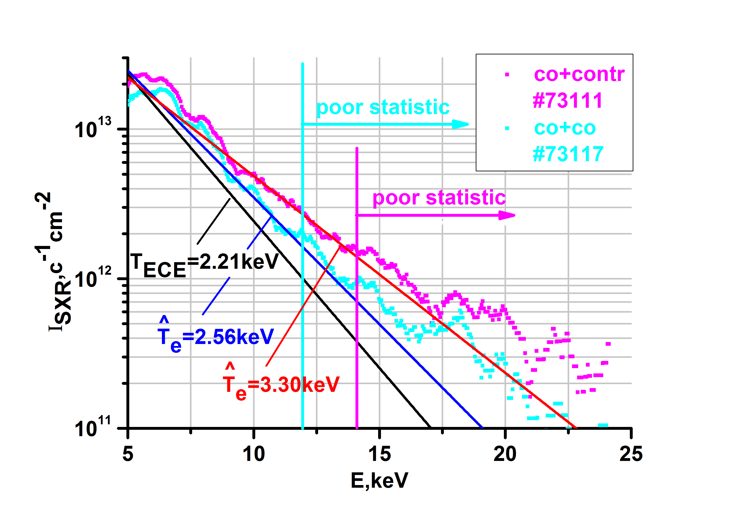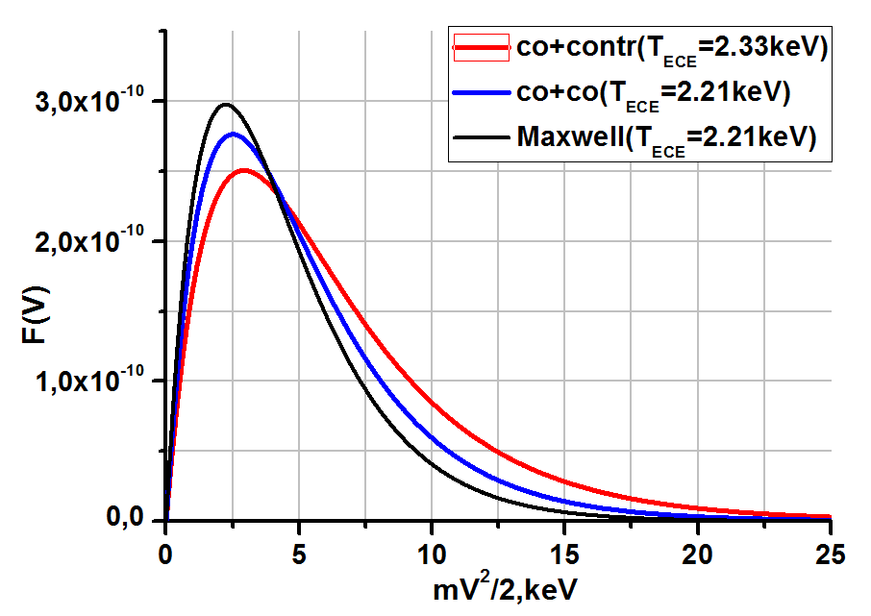
Fig.1. Averaged spectra (PHA data). Fig.2. Velocity distribution function vs energy.
References
- “Optimization of HF-injection at the 2nd harmonic of ECRH on T-10 tokamak in order to obtain high energy content in plasma”, A.Borschegovskiy, S.Neudatchin, I.Pimenov, V.Trukhin, M.Dremin, A.Kislov, Yu.Pavlov, EPJ Web of Conferences 203, 02004 (2019)

*) abstracts of this report in Russian

