Optical emission spectroscopy study of microwave plasma in methane-Hydrogen-silane mixtures in process of SiC and composite SiC-diamond films deposition *)
DOI: 10.34854/ICPAF.2021.48.1.127
¹Yurov V.Yu., ^{1,2}Ralchenko V.G., ¹Martyanov A.K., ^{1,2}Antonova I.A., ¹Sedov V.S., ¹Shevchenko M.Y. and ¹Bolshakov A.P.
¹Prokhorov General Physics Institute, Russian Academy of Sciences, Vavilov str. 38, Moscow 119991, Russia, office@gpi.ru
²National Research Nuclear University MEPhI, 31 Kashirskoyeshosse, Moscow, 115409, Russia, info@mephi.ru
Microwave plasma chemical vapor deposition (MPCVD) in silane-hydrogen and silane-hydrogen-methane mixtures is effectively used for growth of SiC and SiC-diamond composite films [1], however, the properties of the silane-containing MW plasma at pressures of the order of 100 Torr still are poorly explored. Here we characterize the MW plasma (2.45 GHz) in SiH₄+H₂ and SiH₄+СH₄+H₂ mixtures (72 Torr) with silane concentration in the process gas ranging from zero to 5% using high resolution optical emission (OE) spectroscopy. Besides the OE lines of C₂ dimer, Balmer series of excited atomic hydrogen H_{α}, H_{β}, H_{γ}, H_{δ}, Hε, and CH radical we observed atomic Si lines at 263, 288 and 391 nm and a relatively weak SiH emission, the Si atoms being the main Si-related specie in the plasma (Fig. 1a). Gas temperature T_{g} of ≈3160 K was estimated from intensities of rotational lines of C₂ dimer (Δν=0, λ=516.5 nm) emission band. The absorbed microwave power density in the plasma wherein was between 36 and 43 W/cm³ with a slight tendency to decrease with silane addition. The intensities of H, C₂ and Si lines in the OE spectra show an obvious kink of slope at ≈0.5%SiH₄ on the plot vs silane concentration in H₂ and H₂ + CH₄ mixtures (Fig. 1b). Also, the microwave power density, T_{g}, and intensity ratio H_{α}/H_{β} (sensitive to electronic temperature T_{e}) all show a clear extremum near the critical point at ≈0.5%SiH₄. We will discuss possible reasons for the observed dynamics of the plasma parameters, and will describe structure and properties of the grown 3C-SiC and SiC-diamond composite films.
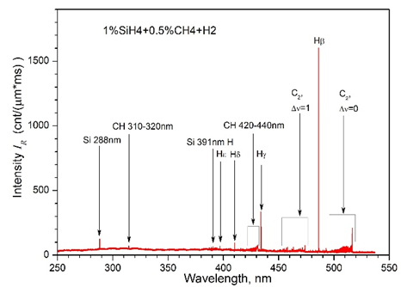  (a) | 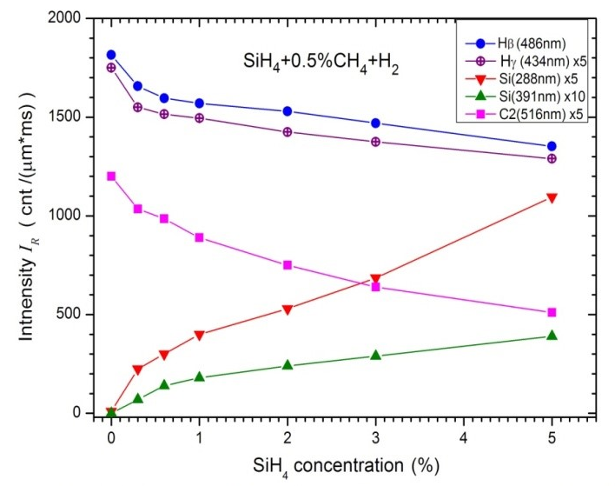  (b)
Fig.1. (a) OE spectrum for the plasma in 1%SiH₄+0.5%CH₄+H₂ mixture. (b) Intensities of emission lines of Si 288 nm, Si 391 nm, H_{β}, H_{γ} and C₂ (516 nm) vs silane content in SiH₄+0.5%CH₄+H₂ mixture.
This work was supported by Russian Fund for Basic Research, grant № 18-29-11023.
References
- V.S. Sedov, A.K. Martyanov, A.A. Khomich, S.S. Savin, V.V. Voronov, R.A. Khmelnitskiy, A.P. Bolshakov, and V.G. Ralchenko, Diam. Relat. Mater. 98, 107520 (2019).

*) abstracts of this report in Russian

