NONLINEAR WAVES IN HALL MAGNETIC HYDRODYNAMICS [1]*)

DOI: 10.34854/ICPAF.2021.48.1.112

Savelyev V.V.

Keldysh Institute of Applied Mathematics RAS, Russia, Moscow, ssvvvv@rambler.ru

Hall magnetic hydrodynamics (HMHD) is a classical magnetic hydrodynamics (MHD) taking into account the Hall effect [1,2]. In this paper, we study nonlinear waves in HMHD. One-dimensional equations and their solutions in the form of traveling waves are considered. In contrast to [3], the finite temperature is taken into account in the isothermal approximation. As shown in the paper, the question of the existence and properties of such waves is reduced to the study of the following ODE system -

 (1)

Here- components of the magnetic field in the plane perpendicular to the direction of wave propagation (axis ),  - parameters. It is shown that this system is Hamiltonian with a Hamiltonian . Level lines  are phase curves. The singular points of system (1) can only be of two types - centers and saddles. The centers are periodic solutions, and the saddles correspond to solitary waves. As follows from (1), there are two branches of solutions for these waves (signs ( + ) or ( - )) in (1). These branches differ in both parameters and properties of the solution. As examples, the figure shows solitary waves for two branches - the left one is a sign ( + ), and the right one is a sign ( -).

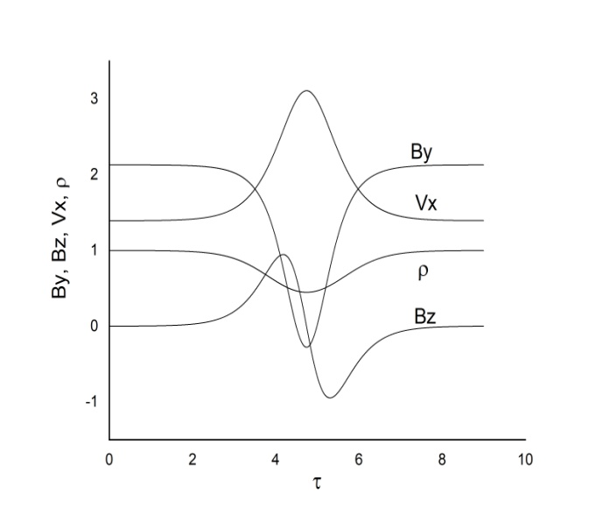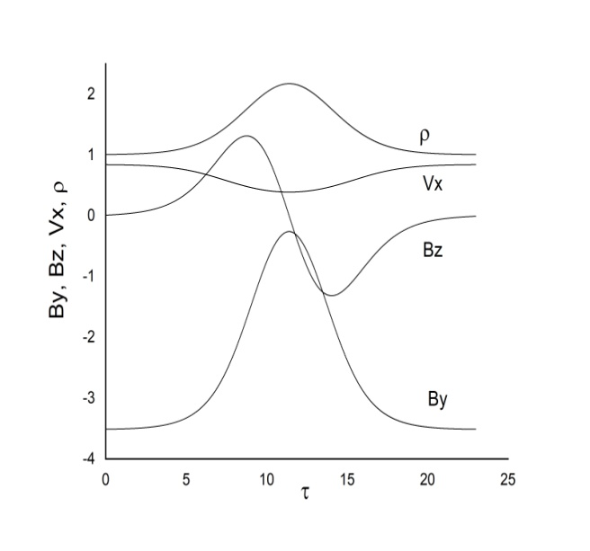

The author is grateful to M. B. Gavrikov for useful discussions.

References

1. Кадомцев Б.Б., Коллективные явления в плазме, 2-е издание. М., Наука, Глав. редакция Физ.-Мат. Лит., 1988
2. Морозов А.И. , Введение в плазмодинамику, 2-издание, М., ФИЗМАТЛИТ, 2008
3. V.V Savelyev 2018 J. Phys.: Conf. Ser. 1094 012031

1. *) [abstracts of this report in Russian](http://www.fpl.gpi.ru/Zvenigorod/XLVIII/Lt/ru/EO-Savel'ev.docx)