recovery of the electron density’s linear integral in the case of non-monotonic profile *)
DOI: 10.34854/ICPAF.2021.48.1.165
^{1,2,3}Afonin K.
¹AO “GNC RF TRINITI”, Russia, kirill.afonin@phystech.edu
²Moscow Institute of Physics and Technologies(national research university)
³Fusion Centre
The key element of the discharge support in ITER is the fuel injection (D, T) in the form of frozen pellet capsules. When pellets are introduced, local density peaks appear at the edge of the plasma, which are higher in height than the central density [1].
Due to the non-monotonic nature of the profile with respect to the toroidal field flux, the measurement of the plasma density profile by reflectometry methods in the region between the peaks is impossible. Measurement of the plasma density integral along the line of sight (<nl>) via refractometry is possible, but it is difficult to approximate a non-monotonic profile with enough precision, since the relative error in determining <nl> should not exceed 1% [2].
As part of the study, two methods for determining <nl> were considered: the method assumed in refractometry to determine density profiles that are monotonic with respect to the coordinate of the toroidal flow, and the method using data from both refractometry and reflectometry to measure the profile to peaks and restore the density profile in the interval between the peaks. The measurement errors are shown in Figure 1. The figure shows how, in the case of the method for monotonic profiles, the systematic error increases with the growth of local peaks, while the growth of peaks has no effect on the combined method of reflectometry and refractometry.

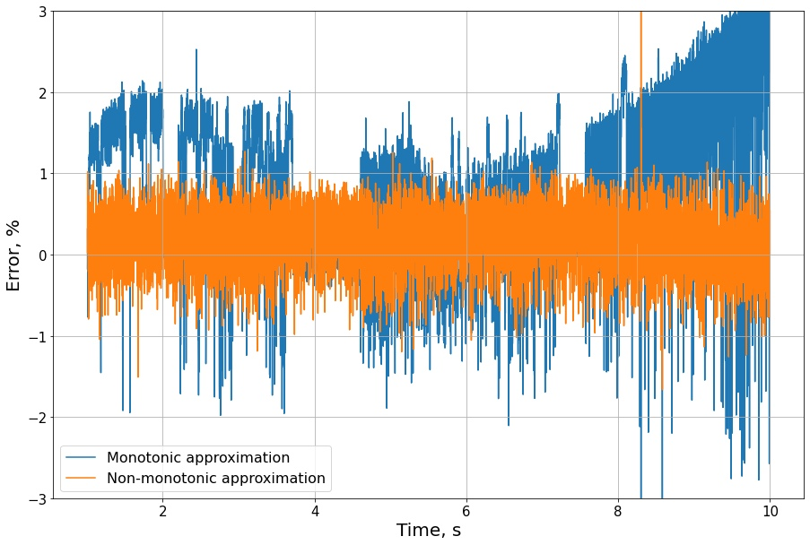

References
- Polevoi A. R. et al. Integrated modelling of ITER scenarios with DT Mix control //45th EPS Conference on Plasma Physics. – European Physical Society, 2018.
- System Design Description (DDD) 55.F9 Reflectometry High Field Side [3WD9DT]

*) abstracts of this report in Russian

