"X-RAY PIT" PARADOX AS AN INDICATOR OF THE LONGITUDINAL ELECTRON TRANSPORT IN TOKAMAKS *)
DOI: 10.34854/ICPAF.2020.47.1.006
Mirnov S.V.
JSC "SSC RF TRINITI (Troitsk Institute of Innovative and Thermonuclear Research)", Moscow, Troitsk, Russia, mirnov@triniti.ru
An apparently inexplicable phenomenon observed in laboratory tokamaks is analyzed - an active decrease in the intensity of the soft x-ray radiation (SXR) of tokamak plasma passing through the Be foils as their thickness increases and the electron density of the plasma decreases ("x-ray pit", figure left). An explanation of this phenomenon is proposed by involving the assumption of the "depletion" of the Maxwell distribution in space of electronic velocities exceeding 3-5 times the thermal one. The anomalous transfer of electron heat along a weakly perturbed toroidal magnetic field (the "magnetic flutter" model [1,2]), postulated for tokamak, could be a probable cause of this "impoverishment". Thus, the "x-ray pit" would be a new tool for studying the physical nature of anomalous electron transport in tokamaks. Other possible manifestations of longitudinal electron transport in tokamaks and stellarators are discussed, in particular, a drop in plasma lifetime and degradation of the plasma electrical potential during ECR heating [3,4].
With support of ROSATOM grant from 13.09.2019 № 313/1694-Д
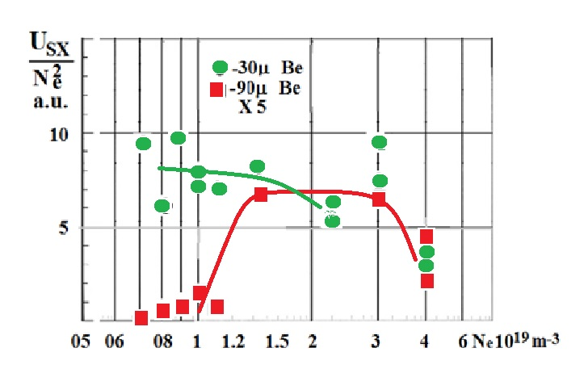
Figure - Evolution of soft x-ray radiation (1-6kev), passed Be – 30 mk (circles) and 90 mk (squares, multiplied by 5 times ) via the electron density of tokamak T-11M plasma, "x-ray pit" is left.
References
- Callen J.D. Phys. Rev. Lett. 1977 V.39 p 1540.
- Kadomtsev B.B., Pogutse O.P. Plasma Phys. and Controlled Nucl. Fus. Res. IAEA Vienna 1979 V.1 p. 649-663.
- Alikaev V.V. et al. 2000 Plasma Phys. Rep. 26 917.
- Melnikov A.V. et al. Plasma Phys. Control. Fusion 60 (2018) 084008.

*) abstracts of this report in Russian

