STRUCTURE OF MICROPLASMA DISCHARGE ON THE SURFACE OF TITANIUM *)
DOI: 10.34854/ICPAF.2020.47.1.172
Ivanov V.A., Konyzhev M.E., Kamolova T.I., Dorofeyuk A.A.
A.M. Prokhorov General Physics Institute of RA S, Moscow, Russia, ivanov@fpl.gpi.ru
It is known that a dense plasma flow in vacuum can initiate microplasma discharges (MPDs) on the surface of metals coated with a dielectric film [1]. These discharges arise as a result of an electric discharge (breakdown) between the outer surface of the film charged in the plasma flow and the clean metal surface [2].
In this work, we studied the spatial structure of visible light from a single microplasma discharge (MPD), and also studied a micro-structure erosion of the titanium surface as a result of the excitation of a single microplasma discharge with a duration of 100 μs. This discharge was initiated on the titanium surface by a single pulsed plasma flow (pulse duration 25 μs, electron temperature 10 eV, plasma density 10¹² cm^{–3}) and was powered by a pulsed current source (400 A, 100 μs) in vacuum at a residual air pressure of 1 Pa.
A titanium sample was a grinded plate with dimensions of 2×2 cm², and a thickness of 0.6 mm. It was previously degreased in hexane and ethanol. Wherein, a titanium dioxide dielectric film with a thickness of about 10 nm is naturally formed on the surface of titanium in air atmosphere. After that, a titanium sample was placed in a vacuum chamber at a distance of about 2.5 cm from the plasma injector.
The spatial structure of visible light emitted by a single microplasma discharge on the titanium surface was registered using a digital camera (Fig. 1). The micro-structure erosion formed on the titanium surface (processed by a single microplasma discharge with a duration of 100 μs) was studied using a scanning electron microscope (Fig. 2).
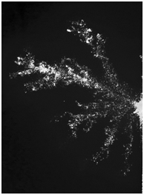 | 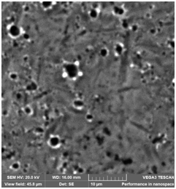 | Fig. 1. Integrated photograph of a single microplasma discharge with high spatial resolution. The size of the discharge region is 1 cm horizontally and 1.4 cm vertically.  Fig. 2. Micro-photograph of surface erosion on titanium as a result of the excitation of a single microplasma discharge. The horizontal and vertical sizes are 46 microns.
Fig. 1 | Fig. 2
It was found, that the spatial structure of visible light of microplasma discharge on titanium is a collection of brightly luminous local points. Wherein, micro-structure erosion of titanium surface is a system of single craters (with characteristic size of 0.3 – 3 microns), located at brightly luminous local points. The average velocity of the discharge propagation over the titanium surface is 100 m/s.
The studies were carried out according to the state task "Fundamentals of Plasma, Microwave and Radiation Technologies" (AAAA-A18-118022090096-6).
References
- Ivanov V.A., Sakharov A.S., Konyzhev M.E., Plasma Physics Reports, 2008, V. 34, No. 2, pp. 150–161.
- Ivanov V.A., Sakharov A.S., Konyzhev M.E. et al., Journal of Physics: Conf. Series 907 (2017) doi:10.1088/1742-6596/907/1/012023

*) abstracts of this report in Russian

