BEHAVIOR OF TUNGSTEN EVAPORATION ENERGY UNDER THE HEATING BY A HIGH POWER PULSED PLASMA FLOW *)
DOI: 10.34854/ICPAF.2020.47.1.168
¹Kazeev M.N., ¹Kozlov V.F., ¹Koidan V.S., ²Herdrich G., ²Schmidt J.
¹NRC “Kurchatov Institute”, Moscow, Russia, Kazeev_MN@nrcki.ru
²Stuttgart University, Stuttgart, Germany, herdrich@irs.uni-stuttgart.de
In [1], the experiments and numerical analysis of the behavior of surface layers of high-temperature metals in their interaction with a pulsed plasma flow produced by a high-power ablative pulsed plasma thruster given. Data on heating and evaporation of steel and tungsten specimens presented. The subject of this paper is to determine the evaporation energy of tungsten satisfying the measurements and the model. The plasma thruster used for the investigation produces plasma flows with a directed velocity of (7–9) × 106 cm/s, an initial diameter of 1.5–2 cm, and a maximum number density of about 1018 cm–3, as well as a maximum power of 5 GW [2].
The absorbed energy and the mass evaporated from tungsten and steel specimens as functions of the energy stored in the power supply source are shown in Fig. 1. There is an increase in residual heating with increasing of the bank energy. Apparently, this is due to increase of the evaporation temperature.
The experimental data were processed using a numerical model describing the heating and evaporation of the material as a result of the absorption of pulsed energy fluxes, taking into account the evaporation kinetics based on the Hertz–Knudsen expression. Validation of the model is performed using the residual temperature of the specimen and the evaporated mass. The evaporation behavior of tungsten is investigated up to specific powers of 1 GW/cm2. Comparison of the experimental data and numerical calculations allowed evaluating of the evaporation kinetics at temperatures exceeding the tungsten evaporation temperature under normal conditions. According to calculations, at specific power at or above 50 MW/cm2, the calculated residual temperature exceeds the experimental one. Acceptable consistency with experimental data takes place while decreasing the evaporation energy compared to its table value.
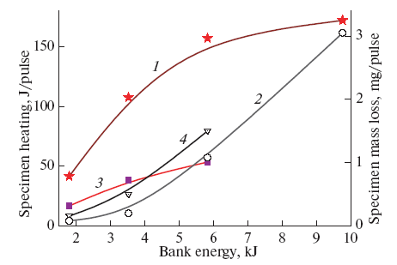
Fig. 1. Absorbed energy and mass loss of steel and tungsten specimens as functions of the energy stored in the power supply source: (1, 2) tungsten temperature and mass loss and (3, 4) steel temperature and mass loss
References
- M.N. Kazeev, V.F. Kozlov, V.S. Koidan, G. Herdrich, and J. Schmidt, // Plasma Physics Reports, 2019, Vol. 45, No. 5, pp. 445–453.
- M.N. Kazeev, in Encyclopedia of Low-Temperature Plasma, Ed. by V. E. Fortov (Nauka, Moscow, 2000), Vol. III, p. 493 [in Russian].

*) abstracts of this report in Russian

