FORMATION OF THE POTENTIAL BY A PLASMA FLOW IN A MAGNETIC BARRIER [1]*)

DOI: 10.34854/ICPAF.2020.47.1.152

1Bardakov V.M., 2Kazantsev A.V., 2Nguyen The Thang, 2Strokin N.A., 2Stupin A.N.

1Irkutsk State Transport University, [vmbardakov38@mail.ru](mailto:vmbardakov38@mail.ru),  
2Irkutsk National Research Technical University, [ivsd55@yandex.ru](mailto:ivsd55@yandex.ru), [kazanets@gmail.com](mailto:kazanets@gmail.com),  
 [nguen.tkhe@yandex.ru](mailto:nguen.tkhe@yandex.ru), [strokin85@inbox.ru](mailto:strokin85@inbox.ru), [al.stupin1@yandex.ru](mailto:al.stupin1@yandex.ru)

It is important for plasma-optical mass separation to ensure high performance, which is determined by the performance of the plasma source and is limited by losses in the transverse magnetic field of the azimuthator (MB), which is one of the elements of the POMS-E-3 mass separator [1]. If only a stream of ions with an average energy moves in the MB, the maximum ion density *N*1 at the exit from the MB is , where *A* is a constant; Δ is the width of the gap across the magnetic field *B* [2]. Diffusion of electrons in a transverse magnetic field is possible in collisions with neutrals and anomalous diffusion. In this paper, the limitation of the density of ions in the case of the classical electron diffusion mechanism is investigated. The determining factor is the distribution of potential in MB, for which the following equation is obtained: , where  is the dimensionless potential;  – coordinate across the field; *g* and *f* are known potential functions; ; *K* is a constant; *σea* is the cross section of elastic electron collisions on neutrals; *na* is the density of the neutral gas; *n*0 is the plasma density at the entrance to the MB; *ωBe* = *qB*/*m* is the electron cyclotron frequency.

The plasma potential inside the MB has a decisive effect on the movement of ions. In Fig. 1 shows the distribution of the dimensionless potential *ψ* = *qφ*/*W*0 in the interval Δ obtained by solving the equation for the potential.

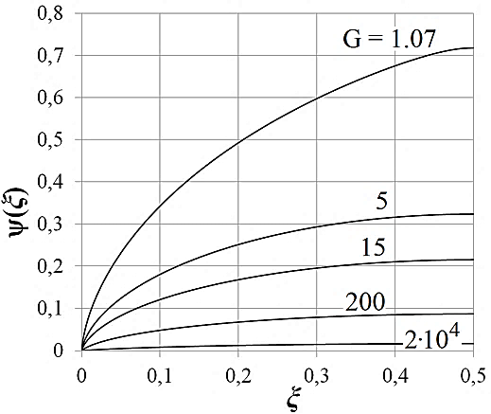If the parameter *G* ≥ *Gcr* ≈ 1.07, then in the entire interval of the azimuthator quasi-neutrality is preserved, and the maximum possible density of ions *N* at the exit from the azimuthator in the regime *G* ≥ *Gcr* is determined as follows: . For the experimental conditions at POMS-E-3, *W*0 = 500 eV; *na* = 1017 m–3; *B* = 0.2 T; *σea* = 24·10–20 m–2; Δ = 0.01 m and *N* = 4.75·1017 m–3, with *N* >> *N*1 = 1015 m–3. Thus, theoretically, for a plasma-optical mass separator there are no real performance restrictions associated with the influence of the magnetic barrier of the azimuthator.

Fig. 1. Potential distribution for various values of the parameter G ().

References

1. Bardakov V.M., Kichigin G.N., Strokin N.A., [Tech. Phys. Letters](http://link.springer.com/journal/11455), 2010, 36, 185.
2. Bardakov V.M., Ivanov S.D., Kazantsev A.V., Strokin N.A., Stupin A.N., Phys. Plasmas, 2018, 25, 083509.

1. *) [abstracts of this report in Russian](http://www.fpl.gpi.ru/Zvenigorod/XLVII/Pt/ru/GG-Strokin.docx)