DETERMINATION OF THE CHARGED PARTICLES SOURCE USING SPECTRAL DIAGNOSTICS OF THE T-10 TOKAMAK *)
DOI: 10.34854/ICPAF.2020.47.1.053
^{1,2}Zemtsov I.A., ¹Krupin V.A., ¹Nurgaliev M.R., ¹Klyuchnikov L.A., ¹Nemets A.R., ¹Dnestrovskij A.Yu., ¹Solovev N.A., ¹Sergeev D.S., ¹Sarychev D.V., ¹Trukhin V.M.
¹NRC «Kurchatov Institute», Moscow, Russia, zemtsov_ia@nrcki.ru
²Bauman Moscow State Technical University, Moscow, Russia
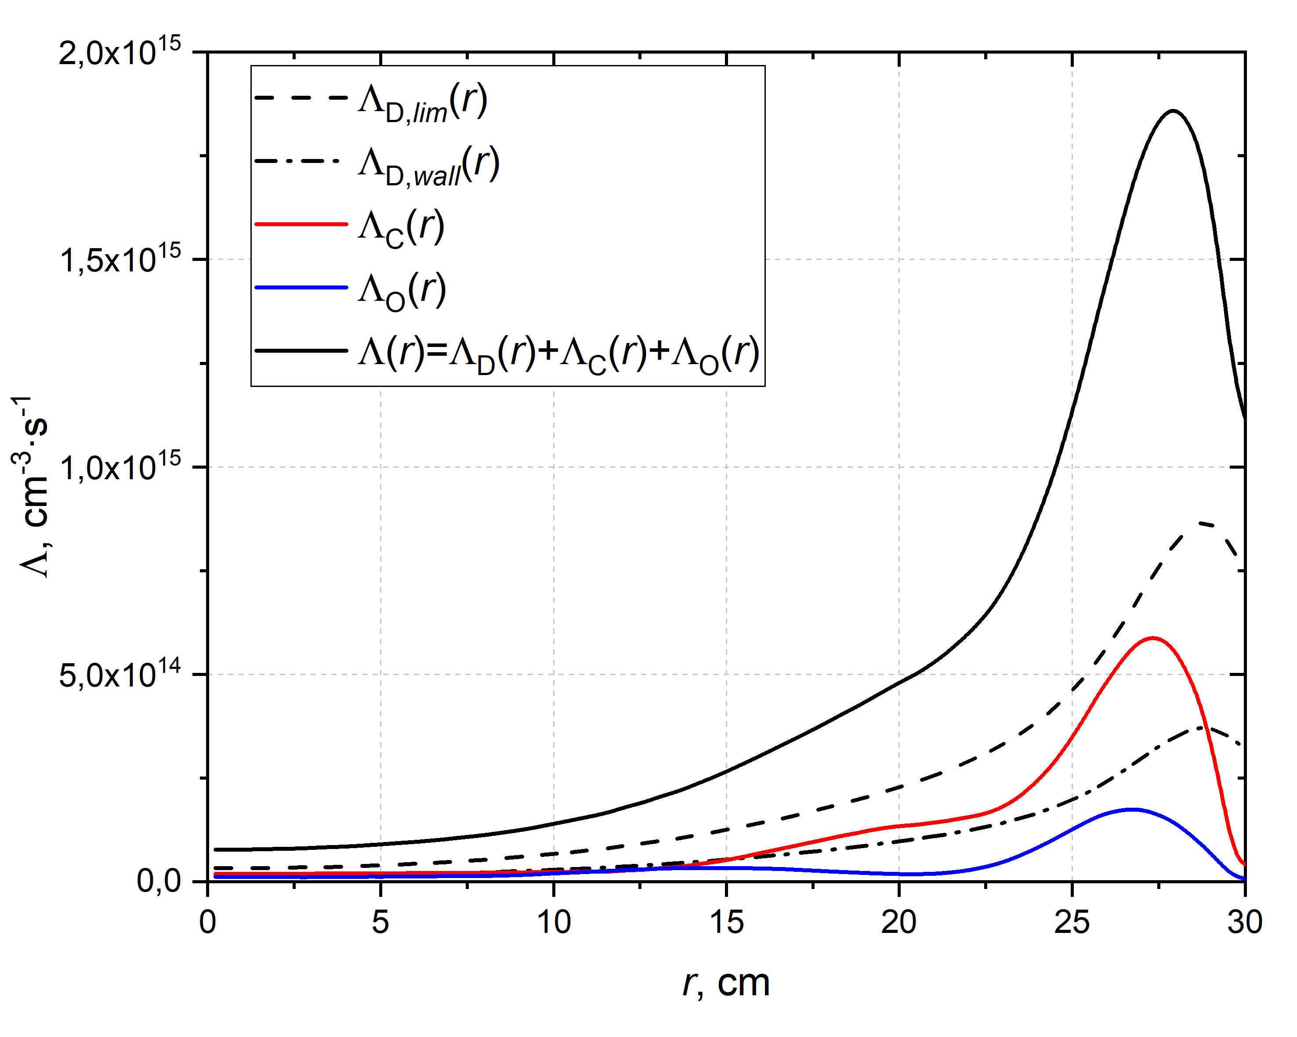
Figure - Profiles of various components of an ionization source of electrons
(T_{e}(0) = 1 keV, n_{e}(0) = 4,2⋅10¹³ cm⁻³)
The paper is dedicated to the evaluaton of the electrons and ions source magnitude Λ, carried out by processing the data from spectroscopic measurements of the main gas and impurities lines.
The total value of the electron source was determined as the sum of the sources created by the atoms of the main gas (Λ_{D}), as well as by the atoms and ions of impurities C (Λ_{C}) and O (Λ_{O}). Λ_{D} consisted of two components: a wall source averaged over the torus surface (Λ_{D,wall}) and a local source from the zone near the limiters (Λ_{D,lim}).
Λ_{D,lim} is determined from the radiation intensity of the D_{α} line in the limiter section of the tokamak recorded with an endoscope. To obtain absolute values of D_{α} intensity, the absolute calibration of the endoscope was carried out using a calibrating source. Λ_{D,wall} is determined as a result of calculations of D atoms radial transport using the ASTRA code. Two components of the flux of deuterium atoms from the chamber wall were taken into account: “cold” one (3 eV, D^{kond}) and “hot” one (50 eV, D^{heat}). The energy and the ratio of their concentrations n_{D}^{kond} / n_{D}^{heat} = 5 / 1 is determined from the analysis of the spectrum of the D_{α} line. The boundary condition n_{D}(a_{L}) was set from the condition of coincidence with the absolute brightness of D_{α}. The ionization sources from impurities Λ_{C} and Λ_{O} are determined by describing in the model the radial profiles of the densities of carbon and oxygen nuclei determined from CXRS measurements. The ionization states of impurities were calculated using the STRAHL code taking into account neoclassical and anomalous transport coefficients [1].
The calculations made it possible to establish the spatial dependence of the source power on the radius, presented in the Figure. It is mostly concentrated in the region (0.75...1) ⋅ a_{L}. From the endoscopic measurements, it is found that the ratio between fluxes Λ_{D,wall} and Λ_{D,lim} is as 1 to 2...3. The fraction of the electron source from the plasma impurities (carbon, oxygen) does not exceed 25% in OH discharges with a value of Z_{eff} ~ 2...3.
The power of the electron source integrated over the cord is ~2 ⋅ 10²¹ electrons/s. The density of neutral atoms at the cord boundary is n_{D} ~0.7 ⋅ 10¹⁰ cm⁻³.
References
- V.A. Krupin et.al. Plasma Phys. Control. Fusion 60 (2018) 115003 (20pp)

*) abstracts of this report in Russian

