Determination of the molar fraction of metastable oxygen molecules in the O2 discharge using optical emission spectroscopy *)
DOI: 10.34854/ICPAF.2020.47.1.223
Bogdanova M., Lopaev D., Volynets A., Zyryanov S., Rakhimov A.
SINP MSU, Moscow, Russia, bogdanova.marya@mail.ru
Oxygen plasma is found in many applications as a source of active particles: oxygen atoms in the ground state O(³P), as well as metastable oxygen molecules O₂(a¹Δ_{g}) and O₂(b¹Σ_{g}⁺). The fraction of these particles in the oxygen plasma can be quite large: for example, the degree of dissociation in the oxygen plasma can exceed 20%, and the fraction of O₂(a¹Δ_{g}) can reach ~ 15–20% [1, 2]. For the correct simulation of discharges in oxygen, it is important to have reliable data on the rates of plasma-chemical processes involving O atoms and metastable oxygen molecules, as well as the molar fraction of these particles in the discharge. Despite the fact that oxygen plasma has been studied for quite long time, new diagnostics are now appearing, which make it possible to substantially refine the available kinetic schemes used to model O₂ plasma.
The main goal of this work was to determine the molar fraction of the O₂(a¹Δ_{g}) and O₂(b¹Σ_{g}⁺) molecules in the O₂ plasma of the poorly studied average pressure range (~10-100 Torr) by optical emission spectroscopy (OES), i.e., by the plasma emission spectrum. The advantages of this approach are obvious - non-invasiveness of such a technique, the ability to conduct in situ measurements.
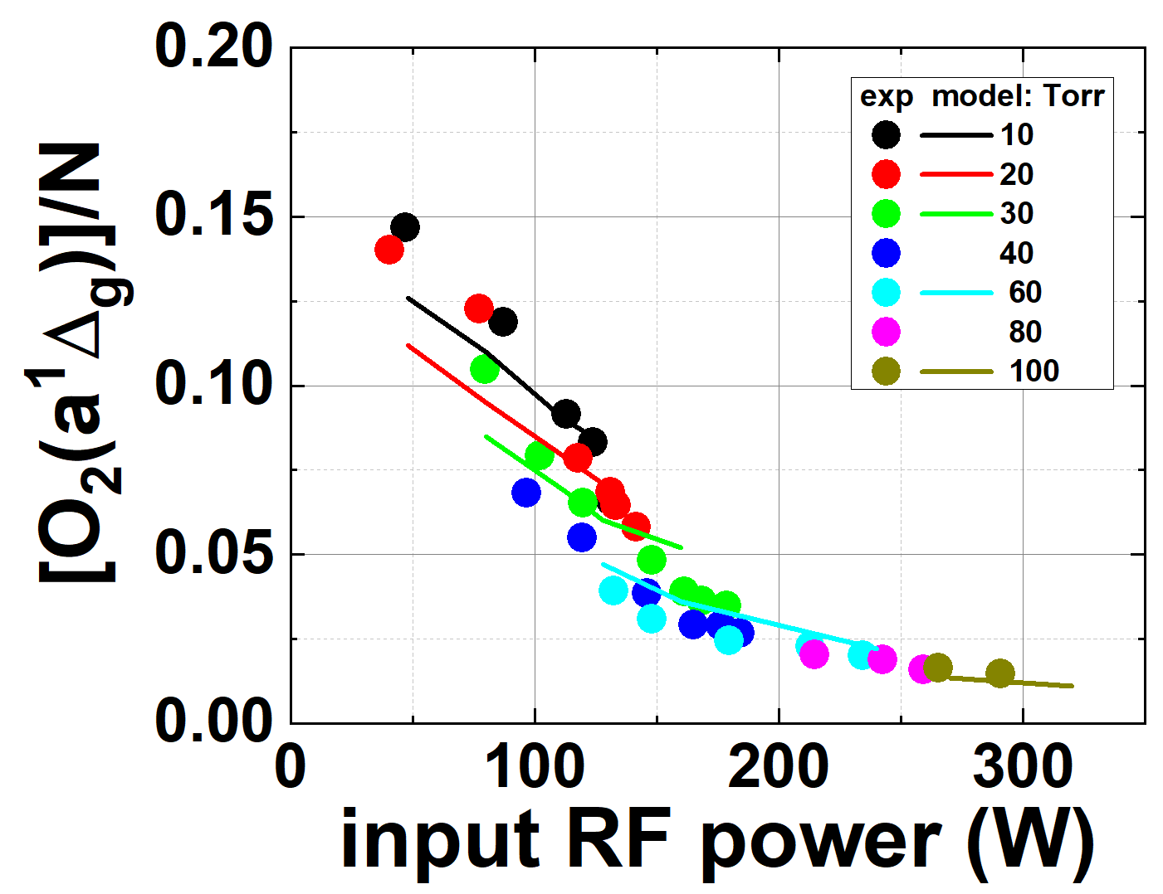
O₂ plasma was created in a quartz tube (length 200 mm and inner diameter 10 mm) at pressures of 10-100 Torr using a transverse capacitive discharge at a frequency of 81 MHz with external electrodes along the entire tube. To maintain almost constant conditions on the surface of the tube, the electrodes were cooled with water. A special carbon insert provided good thermal conductivity between metal and glass. The RF power introduced into the plasma was in the range from 50 to 350 W and was determined locally from direct measurements of the RF voltage and current, as well as the phase shift between them.
The experimentally determined values ​​of the molar fraction of O₂(a¹Δ_{g}), together with the experimental results on the gas temperature and molar fraction of atoms, were in good agreement with the predictions of the independent self-consistent model of the discharge. This allows to analyze the kinetic scheme of such models.
This research was conducted in the scope of the KaPPA International Associated Laboratory (LIA), performed within the LABEX Plas@par project ANR-11-IDEX-0004-02. This work was also supported by Russian Foundation of Basic Research (RFBR) projects No. 16-52-16024 and 18-32-00932\19.
References
- J.P. Booth, et.al. Plasma Sources Sci. Technol. 28 (2019) 055005
- O.V. Braginsky, et.al. J. Phys. D: Appl. Phys. 41 (2008) 172008

*) abstracts of this report in Russian

