Investigation OF the NEGATIVE LEADERS FORMATION USING LASER probing METHODS *)
DOI: 10.34854/ICPAF.2020.47.1.114
Agafonov A.V., Zakharov S.M., Medvedev M.A., Oginov A.V., Parkevich E.V., Khirianova A.I.
P.N. Lebedev Physical Institute of the Russian Academy of Sciences, 53 Leninskiy Prospekt, 119991, Moscow, Russia, medvedevma@lebedev.ru
The development of the lightning current channel represents the growth of a negative leader starting from a negatively charged thundercloud towards a positively charged earth. At present, the physical phenomena accompanying the development of lightning, such as the generation of hard radiation and neutrons [1,2], do not have a full explanation. In this work, we have studied the features of the formation and development of leader channels using laser probing methods. The sketch of the laser diagnostics is shown in Figure 1. The discharge was generated on the ERG setup [3] in the tip-sphere electrode configuration, with a gap between the electrodes of 60 cm. The high-voltage electrode was the tip, to which a negative voltage pulse with an amplitude of ~ 1.4 MV and a duration of ~ 2 μs was supplied. The maximum generator current was ~ 10 kA. Typical current and voltage waveforms are shown in Figure 2 (a). Laser probing methods included interferometry, shadow and schlieren photography of the discharge. Typical shadow and schlieren photographs are shown in Figures 2 (b), (c). The laser was synchronized using a narrow-band microwave antenna tuned to the radio emission generated by the discharge.
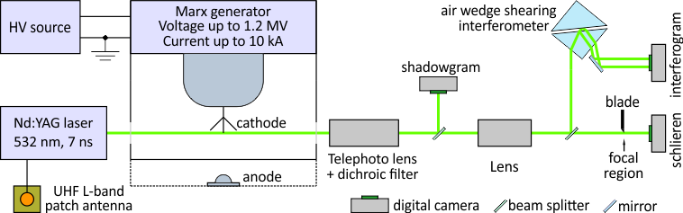
Fig.1. The sketch of the experimental setup.
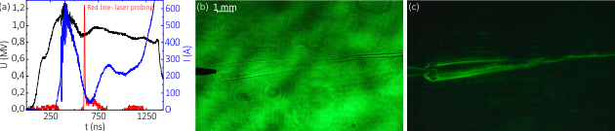
Fig. 2. Waveforms of discharge voltage and current(a), shadow and schlieren images of the discharge. The moment of the laser probing spotted by the red curve on the oscillogram.
This work was supported by the Russian Science Foundation grant No. 19-79-30086. The development of an optical diagnostic system was partially supported by the RFBR grant No. 18-32-00566.
References
- Gurevich, A.V. et al., 2016. Observations of high-energy radiation during thunderstorms at Tien-Shan. Phys. Rev. D 94, 023003. https://doi.org/10.1103/PhysRevD.94.023003
- Dwyer, J.R. et al., 2005. X-ray bursts associated with leader steps in cloud-to-ground lightning. Geophysical Research Letters 32. https://doi.org/10.1029/2004GL021782
- Agafonov, A.V., Oginov, A.V., Shpakov, K.V., 2012. Prebreakdown phase in atmospheric discharges. Phys. Part. Nuclei Lett. 9, 380–383. https://doi.org/10.1134/S1547477112040024

*) abstracts of this report in Russian

