Features of the interaction of plasma flows and the axial magnetic field during implosion of nested conical arrays *)
DOI: 10.34854/ICPAF.2020.47.1.087
¹Aleksandrov V.V., ¹Branitsky A.V., ²Boldarev A.S. , ²Vichev I.Yu., ²Gasilov V.A., ¹Grabovsky E.V., ¹Gritsuk A.N., ¹Mitrofanov K.N., ²Olkhovskaya O.G., ²Sasorov P.V., ¹Shishlov A.O.
¹Troitsk Institute for Innovation and Fusion Research, Troitsk, Moscow, Russia;
alexvv@triniti.ru
²Keldysh Institute of Applied Mathematics, Russian Academy of Sciences, Moscow, Russia
The results of experimental and numerical studies of current implosion in vacuum at the Angara-5-1 installation of a nested conical array with a discharge current pulse of up to 4 MA with a rise time of the leading edge of 100 ns are presented (Fig. 1).
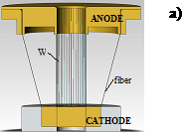 |  | 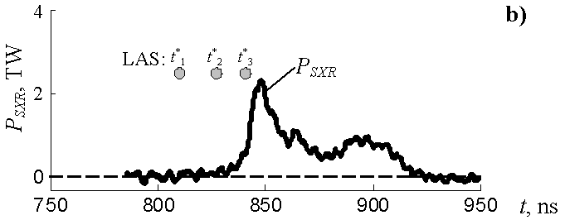
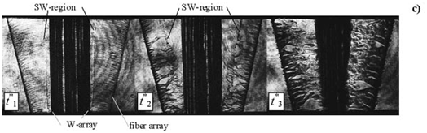
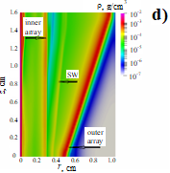
Fig. 1. Cone array: external cascade - conical array of 4 kapron 25 μm fibers, linear mass 22 μg / cm, R_{out}=10/5 [mm]; internal cascade – array of 40 W 6 μm wires, linear mass 220 μg / cm, R_{in}=3 mm. H=16 mm. a) - scheme of the experiment; b) - time dependence MRI power pulse in the spectral range (hν> 100 eV); c) frame images (positive) of the plasma of the nested array obtained by shadow laser probing at various points in time. The frame times t*₁ - t*₃ are indicated by circles (• LAS). The anode is above, the cathode is below; d) - the calculated density distribution at time t = 70 ns, shock waves between cascades; e) - time dependence of the rate of plasma formation (1 - internal cascade, 3 - external cascade) and vaporized mass (2 - internal cascade, 4 - external cascade); f) - distribution along the array radius: 1 - magnetic induction B_{φ}, 2 - magnetic Mach number M_{A} at time t = 70 ns (corresponds to a stable position of the shock wave), in the middle of the array height z = 8 mm.
The work was financially supported by the Russian Foundation for Basic Research (project N. 18-29-21005, N.20-02-00007-a).

*) abstracts of this report in Russian

