ON THE 90TH ANNIVERSARY OF ALEXEY I. MOROZOV
A.B. Kukushkin^{1,2,3}
¹NRC “Kurchatov Institute”, Russia, ²NRNU “MEPhI”, Russia, ³MIPT, Russia
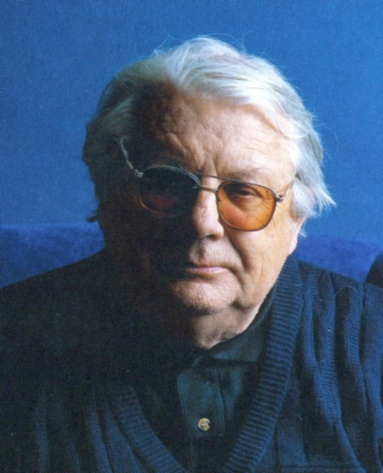
We celebrate 90 years since the birth of Alexei Ivanovich Morozov (03/30/1928 - 05/06/2009), an outstanding scientist in the field of plasma physics, plasma electric propulsion, and controlled thermonuclear fusion, doctor of physical and mathematical sciences, professor, Honored Worker of Science and Technology of the Russian Federation, laureate of the USSR State Prize and prestigious international awards, Chief researcher of the Plasma Theory Department of the National Research Center “Kurchatov Institute”, member of the Russian Academy of Natural Sciences and the French National Aeronautics and Space Academy (AAE) (for details see [1,2] and his main work - the monograph [3]).
A.I. Morozov gained world fame for his pioneering work on the creation and implementation of Stationary Plasma Thrusters (SPT) in space technology. Specialists working in the field of electric propulsion, called Alexei I. Morozov the father of the SPT [4, 5]. A.I. Morozov was awarded the International Medal for the 100th anniversary of the Electric Rocket Propulsion Society (Stuhlinger Medal) (2005), and the AAE Silver Medal (2006).
Another important result of the plasma acceleration activity of A.I. Morozov is the design and creation of a unique Quasi-Stationary Plasma Accelerator (QSPA). The program was implemented in Troitsk, Minsk, Kharkov. Now the QSPA is being actively used in TRINITI in experiments on plasma irradiation of the first wall materials for the ITER tokamak to analyze their erosion resistance.
In the past three decades, A.I. Morozov actively developed the principles of plasma magnetic traps of Galatea type with β ~ 1 (β is the ratio of plasma pressure to magnetic pressure). The experiments were carried out at MIREA and General Physics Institute of Russian Academy of Science.
All the achievements of A.I. Morozov in solving the practical problems are based on his outstanding contribution to plasma theory: the predictions of macroscopic electric field in plasmas with even high electrical conductivity (the idea of the SPT), the filamentary structures in closed magnetic systems (now known as magnetic islands), and the class of trajectories of charged particles in a toroidal magnetic field (now known as "bananas"); theory of axisymmetric flows of a two-component electron-ion plasma and the Hall effect in plasmas; basics of PlasmaOptics. The ability to master the way from the formulation of physical principles through their detailed theoretical analysis and mathematical modeling to the embodiment in the functioning devices made A.I. Morozov an outstanding person in the world plasma physics and its applications.
References
- On the 90-th anniversary of Alexey I. Morozov. Problems of Atom. Sci. & Techn., ser. Thermonucl. Fus., 2018, 41(2), 8-12 http://vant.iterru.ru/vant_2018_2/2.pdf (in Russian)
- https://ru.wikipedia.org/wiki/Морозов,_Алексей_Иванович (in Russian)
- Morozov, A. I. Introduction to plasma dynamics. Boca Raton, FL: CRC Press, 2013.
- Arkhipov A.S., Kim V.P., Sidorenko E.K. Morozov Stationary Plasma Thrusters. Moscow: MAI, 2012, 291 p. (in Russian)
- Kim V., et al. Alexey Morozov – leader of the SPT development in the USSR. Proc. 31st Int. Electric Propulsion Conf., Univ. Michigan, USA, 2009.

