90th ANNIVERSARY OF BORIS BORISOVICH KADOMTSEV
Pastukhov V.P.
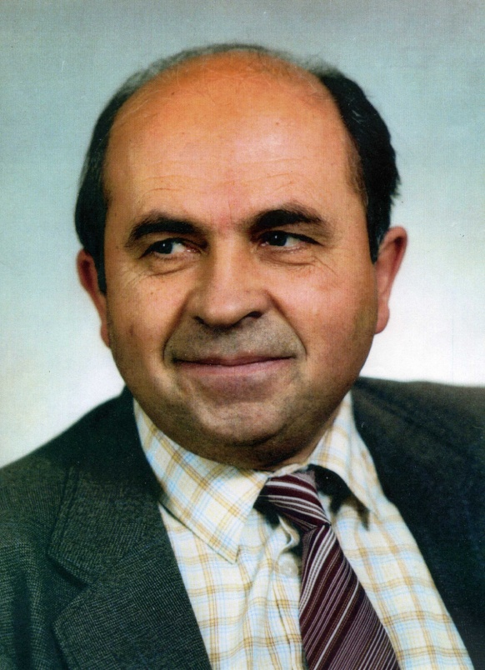
NRC Kurchatov Institute, Moscow, Russia, Pastukhov_VP@nrcki.ru
Boris B. Kadomtsev, who is an outstanding theoretical physicist of the modern time, was born on November 9, 1928. Already his early works performed by him in the 50-s of the last century have revealed his brilliant talent and extraordinary physical intuition those have allowed him later to become a recognized leader of the national and worldwide theoretical study in the field of plasma physics and the controlled fusion. Having extraordinary broad scientific interests,
B.B. Kadomtsev has also given significant contributions to the fundamental issues of nonlinear dynamics of continuous media and quantum mechanics. The scientific and organizational activity of B.B. Kadomtsev as the Director of the Division of Plasma Physics in the Kurchatov Atomic Energy Institute as well as one of the main initiators and inspirers of the international ITER project is well known and internationally recognized.
B.B. Kadomtsev spent his childhood and school years in Penza city. In 1946 he entered, and in 1951 graduated with honors from the Physical Faculty of the Moscow State University. According to the recommendation of the supervisor D.I. Blokhintsev, he got a scientific position in the Institute of Physics and Energy in Obninsk, where in 1954 he obtained the PhD degree. Then he heard about the idea of magnetic confinement of high-temperature plasma and was interested in it. In 1955 he got a position in the Kurchatov Institute in the theoretical laboratory of academician M.A. Leontovich. Coming to the Leontovich laboratory Kadomtsev very quickly performed a number of crucial works on the physical kinetics of plasma, the stability theory and turbulence of plasma in magnetic fields. Soon he became the co-author of the discovery of "Current-convective plasma instability", which was introduced into the State Register of Discoveries of the USSR under No. 78. In 1961 he obtained the degree of Doctor of Science, and in 1962 he was elected to correspondent members of the USSR Academy of Sciences. His studies always included the deep understanding of the essence of the problem, amazing physical intuition, the skillness in a variety of mathematical methods for the solution of problems and the ability to clearly explain the essence of the most difficult physical phenomena. In 1970, together with the experimental group headed by M.S. Ioffe, B.B. Kadomtsev was awarded the State Prize of the USSR and simultaneously he was elected as the actual member of the USSR Academy of Sciences. Since 1976 through 1998 he was Editor-in-Chief of the journal “Physics – Uspekhi”. In 1984, together with a few other leading theorists, B.B. Kadomtsev was awarded the Lenin’s Prize for the research series “Theory of thermonuclear toroidal plasma”, and in 1998 he was honored the John Maxwell Prize, which was the highest award of APS in the field of plasma physics.

