DISTINCTIVE FEATURES OF GAS-DYNAMIC INTERACTION OF HIGH-VOLTAGE TRANSVERSE DISCHARGE WITH SUPERSONIC GAS FLOW
¹Minaev I.M., ²Chernikov V.A.
¹Prokhorov General Physics Institute of the Russian Academy of Sciences, Moscow, Russia
²Lomonosov Moscow State University, Moscow, Russia
A discharge with a mutually perpendicular orientation of the applied electric field and flow is the most common case of electrical discharges in gas flows. It is for such discharges that the flux effect is most significant, leading to the non-stationary nature of the burning of dc discharges [1]. As a consequence, the characteristics of the discharge cannot be considered in isolation, but should be considered together with the characteristics of the external circuit. In this paper, we consider the role of the gas-dynamic factor in the formation of a discharge during the outflow of gas into the submerged space (Fig. 1a) [1, 2].
With the degree of non-design jet n ≥ 4 n ≡ p∗ / p (p∗ is the pressure at the nozzle exit). The gas-dynamic structure of the flow is complex, and is a system in which there are closed areas, the flow velocity and pressure in which undergo significant changes. This paper discusses the effect of flow parameters on the formation of a stable discharge stage (Fig. 1b). Analysis of the pressure field in the combustion region showed that the gas pressure at the interface of the jet and the shock in the mixing region, and the characteristic length of the discharge region determines the steady-state discharge in the flow (Fig. 2 [2]) by the Mach disk from the nozzle edge.
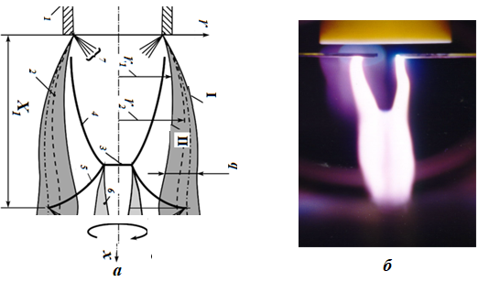
Fig. 1. a flow pattern in the initial part of the supersonic under expanded jet:1 nozzle, 2 mixing layer (δ is the thickness of the mixing layer), 3 Mach disk, 4, 5 hanging and reflected shock waves, 6 shear layer formed overtriple point of intersection of shock waves 3; 7 fan of rarefaction waves, x1 is the length of the first cell of the jet, I and II are the inner and outer surfaces of the mixture layer!saturation at the boundary of the jet, III and IV are the middle of the mixing layer and the conditional boundaryjets; b stable discharge in the stream.
References
- Alferov, V.I., Peculiarities of Electric Discharge in High-Velocity Air Flow with Great Density Gradients, Proc. 3rd Workshop on Magnetoplasma-Aerodynamics for Aerospace Applications, Moscow, 2001, p. 121.
- Erchov A.P., Surcont O.S., Timofeev I.B. and athers. Transverse Electric Discharges in Supersonic Air Flows: Mechanisms of Discharge Propagation and Instability ТВТ. 2004. № 4. p. 516.

