FORMATION OF CHARGED STRUCTURES IN CORONA DISCHARGE
Bychkov V.L., Deshko K.I., Ulianov I.O., Gotovtsev V.V., Chernikov V.A.
Lomonosov Moscow State University, Moscow, Russia, bychvl@gmail.com
Heterogeneous charged structures are of interest from the point of view of the development of electrohydrodynamics for producing charged structures and aerosols. In the corona discharge for the first time, they were obtained experimentally in our works [1] with a corona discharge over the surface of various liquids. This is most clearly was manifested when using alcohol. In this case, columns and disintegrating jets appeared above the surface of the liquid. It is of interest to trace the change in the type of structures, as well as to determine the parameters of aerosol particles with changing discharge parameters. The purpose of this work is to study these issues when using alcohol in the negative corona. The scheme of the experimental device is shown in Fig.1. It consists of a fluid-filled cuvette and an electrical circuit.

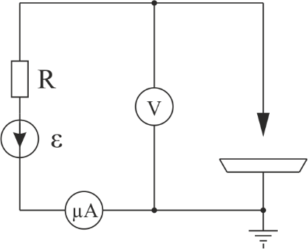
Fig. 1
The upper electrode, or several electrodes, is a needle or a set of needles with a diameter of 2 mm (with a tip radius of 0.4 mm). They were placed at a height of 5–15 mm above the surface of the liquid. The discharge was powered from an adjustable source with an emf of E = 0–30 kV and an internal resistance of R = 100 MΩ. In this case, the current and voltage drop across the discharge gap were recorded.
The cuvettes were made of metal or dielectric. The metal cuvettes were as follows: cylindrical with a diameter of 130 mm, height 18 mm, rectangular 37 x 70 x 122 mm. The dielectric plastic cuvette was cylindrical with a height of 7 mm and a diameter of 10 cm.
At a voltage of 5 kV and a height of 7 mm above the surface of the alcohol, the appearance of a funnel was observed above the surface, at a voltage of 10 kV, columns appeared at the edges of the funnel when the liquid level in the cell was 7–10 mm, which indicated charging of the surface of the liquid. At a lower level, structures did not appear. With increasing voltage, the columns began to collapse in the form of bursting jets with the formation of aerosol particles. The appearance of aerosol particles occurred during the explosion of droplets formed at sharp edges of the funnel.
References
- Aleksandrov A.F., Bychkov V.L., Bychkov D.V., Volkov S.A., Kostyuk A.A., and Chernikov V.A. Electrohydrodynamic Peculiarities of Corona Discharge Interaction with a Liquid Surface. Moscow University Physics Bulletin, 2011, Vol. 66, No. 4, p. 390–397.

