Magnetic pulse sealing of thin-walled cylindrical containers
Grigoriev G.Yu., Kazeev M.N., Kozlov V.F., Koidan V.S., Ryzhkov A.V.
National Research Center "Kurchatov Institute", Moscow, Russia, Kazeev_MN@nrcki.ru
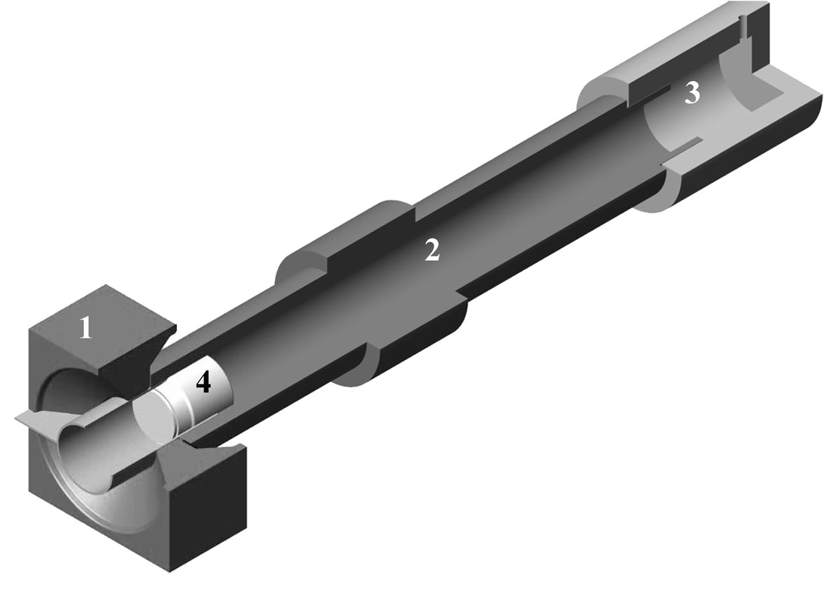
Production of high-quality welded joints of various materials and configurations is a well-known and relevant scientific and technical problem for a number of branches of science and modern technology. The main objective of this work is the development of technology and the creation of equipment for sealing thin-walled cylindrical aluminum containers on a plug of aluminum alloy by magnetic pulse welding. The work was carried out on the“TROB-100” facility of the Kurchatov Institute. This equipment allows to obtain microsecond pulsed magnetic fields with amplitude of up to 300 T and use them in technological processes, in particular, to obtain welded joints [1] and for magnetic-hydraulic deformation of steel cylindrical shells of increased strength [2]. In this work, a magnetic pulse sealing assembly of thin-walled containers using a magnetic pulse welding scheme with an arrangement of the container allowing its free movement in the direction of the axis of symmetry has been developed and tested.
Fig. 1. The main elements of the magnetic pulse seal assembly. 1 inductor, 2 dielectric body, 3 receiver and 4 container.
In this case, during the electric discharge, the container is accelerated in the direction of the axis of symmetry to velocities of the order of 10 m/s. The displacement of the container during discharge is insignificant and does not affect the quality of the weld. In Fig. 1 the main elements of the magnetic-pulse sealing assembly of thin-walled containers are shown. The current position of the container 4 corresponds to the moment of the beginning of its movement in the direction of the receiver 3. The load on the container has decreased significantly compared with the method of its rigid fastening. This method was able to eliminate the deformation of thin-walled containers during welding, which is associated with a significant decrease in the load on the container compared with the method of its rigid fixation. Testing a series of samples showed that the weld provides high quality sealing containers.
References
- Demichev VF, Use of strong pulsed magnetic fields for welding metals. Atomic energy, 1992, vol.73, c. 4, s. 279 – 284, (in Russian).
- Grigoriev G.Yu., Kazeev M.N., Kozlov V.F., Koidan V.S., Senchenkov S.A., Tolstov Yu.S. The study of pulsed magnetic - hydraulic deformation of conductors. Abstracts of the ХLI International (Zvenigorod) Conference on Plasma Physics and TCB. Zvenigorod, February 10 - 14, 2014. Ed. CJSC STC "PLAZMAYOFAN". P. 272.

