formation of an accelerated ion beam using combined dc and inductive rf dischargeS in a longitudinal magnetic field
¹Zadiriev I.I., ¹Kralkina E.A., ¹Vavilin K.V., ²Shvidkiy G.V., ¹Nikonov A.M., ¹Chernikov V.A., ¹Alexandrov A.F.
¹Lomonosov Moscow State University, Moscow, Russia, iizadiriev@gmail.com
²Prokhorov General Physics Institute of the Russian Academy of Sciences, Moscow, Russia
The present work is dedicated to studying accelerated ion beam formation in a combined DC and inductive RF discharge with external magnetic field. Scheme of ion source used in experiments is shown on picture 1. It consists of gas discharge chamber (GDC) in a form of “bottle with a neck” perforated on a thinner end. Cylindrical grounded cathode was placed near the hole. Anode was inside cylindrical part of GDC on flat end opposite to thin perforated one. The diameter of neck with the hole was approximately equal to double length of DC discharge cathode layer. RF antenna connected to RF power source was placed on the cylindrical external surface of GDC. GDC itself was put inside an external magnetic field with predominant longitudinal component. Main physical idea the ion source construction was based on is in the following: flowing to GDC working gas is ionized by the inductive RF discharge and then ions that got into cathode layer should be accelerated outwards from the source. Under such circumstances ion energy is supposed to be defined by the voltage applied between cathode and anode. Additional effect that may influence parameters of ion flow is azimuthal electron drift in the neck area of GDC caused by crossed longitudinal magnetic field and radial component of electric field.
The experiments were carried out using argon flows of 5–20 sccm. Ambient pressure in vacuum chamber was not larger than 2∙10^{–4} Torr. Magnetic field on axis of the ion source was set in a range of 0–40 Gs. Discharge RF power varied from 60 to 200 W, while voltage between cathode and anode – from 0 to 400 V.
The experiments have shown that using pure inductive RF discharge leads to formation of accelerated ion flow on the exit from the ion source with mean energies not exceeding 40 eV. Placing discharge in external magnetic field first causes an increase in plasma glow intensity and density of ion beam. Then, after reaching a certain threshold magnetic field, either discharge is being extinguished or enters a low radiative intensity mode which does not produce ion beam. Applying a DC voltage between cathode and anode in range of 0–300 V leads to increase in ion beam current and mean ion energy. Attempt to set the voltage higher locks discharge inside GDC and prevents the formation of ion beam.
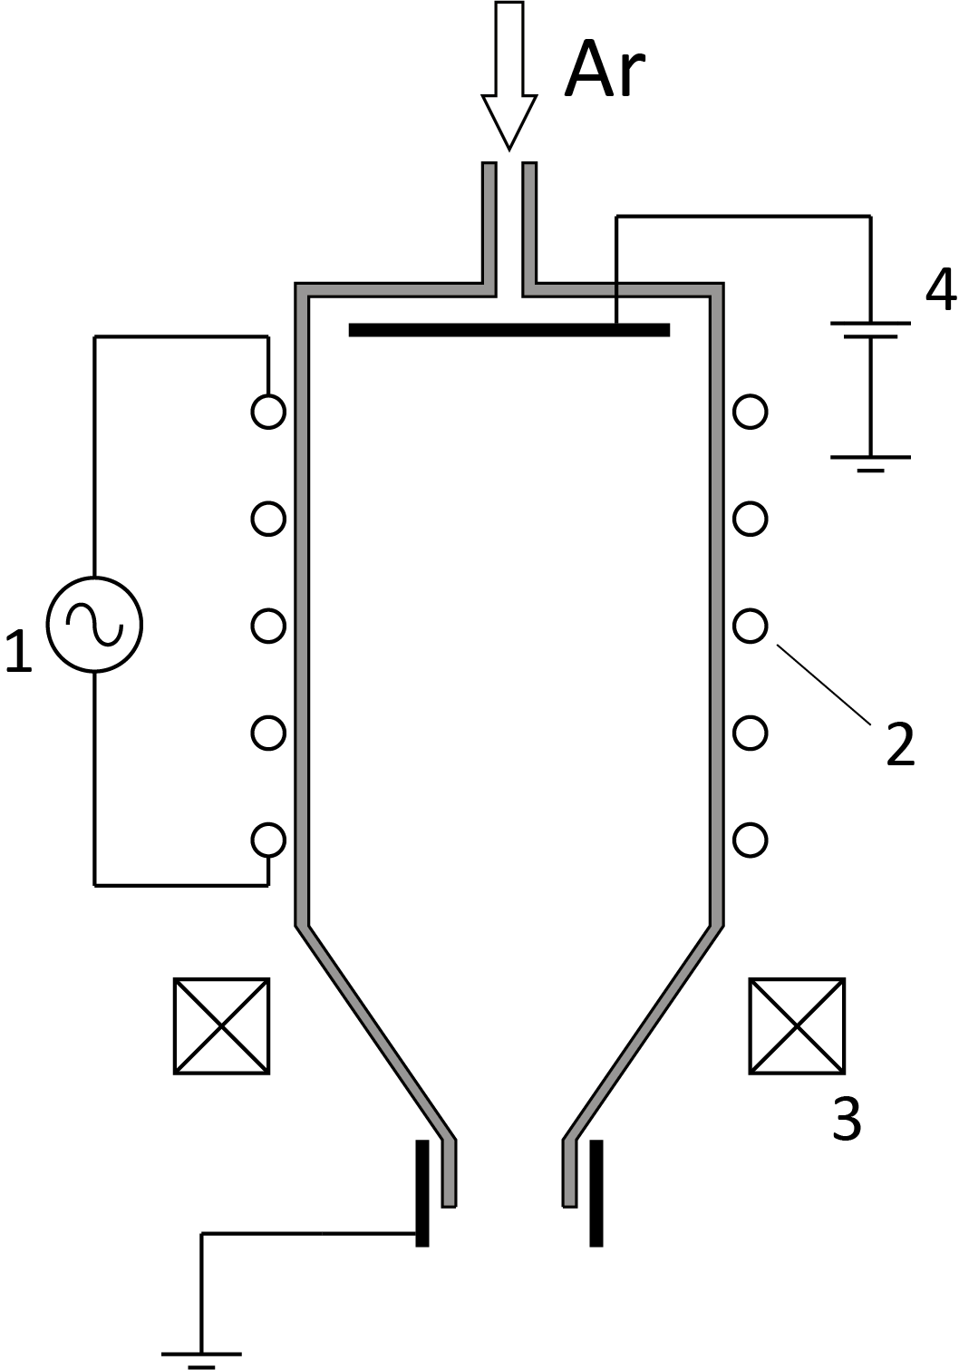
Picture 1. Scheme of laboratory ion source.
1 – RF power source, 2 – RF antenna,
3 – electromagnet, 4 – DC voltage source.

