JUMPs of THE ANODE LAYER IN THE ZONE OF THE E × B DISCHARGE
¹Bardakov V.M., ²Ivanov S.D., ²Kazantsev A.V., ²Nguyen The Thang, ²Strokin N.A., ²Stupin A.N.
¹Irkutsk State Transport University, Irkutsk, Russia, vmbardakov38@mail.ru
²Irkutsk National Research Technical University, Irkutsk, Russia, ivsd55@yandex.ru,
kazanets@gmail.com, nguen.tkhe@yandex.ru, strokin85@inbox.ru, al.stupin1@yandex.ru
Plasma accelerator with an anode layer (TAL), which is based on the Е × В discharge, is one of the main components of the plasma-optical mass separator [1]. The TAL theory (theory of the E × B discharge) gives monotonic dependencies of the discharge parameters on the plasma-forming gas pressure and magnetic field [2]. Experiments, however, tell a different story.
Figure 1 shows an example of a sharp jump of the anode layer (AL) from the near-anode region (spectra 1 and 2) to the cathode (spectra 3–6 in the “cathode layer”) with increasing argon pressure from P = 12⋅10^{–5} Torr to P = 14⋅10^{–5} Torr. The density of ions n (the moment of the distribution function) undergoes a jump: n₃/n₂ ≈ 16.
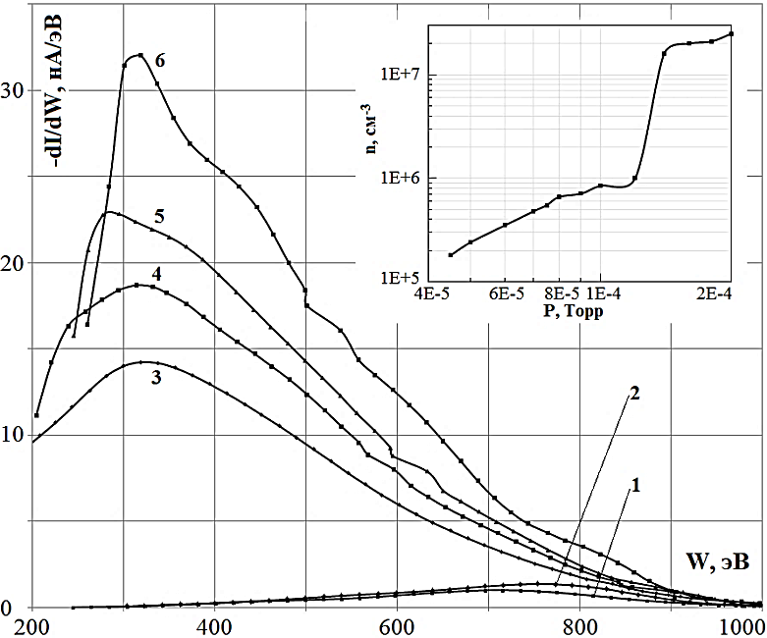
Fig. 1. Evolution of the Е × В-discharge as the pressure of argon changes:
U_{p} = 1160 V; B = 970 G: curve 1 P = 1⋅10^{–4} Torr;2 – 1.2⋅10^{–4}; 3 – 1.4⋅10^{–4}; 4 – 1.6⋅
10^{–4}; 5 – 1.8⋅10^{–4}; 6 – 2⋅10^{–4}.
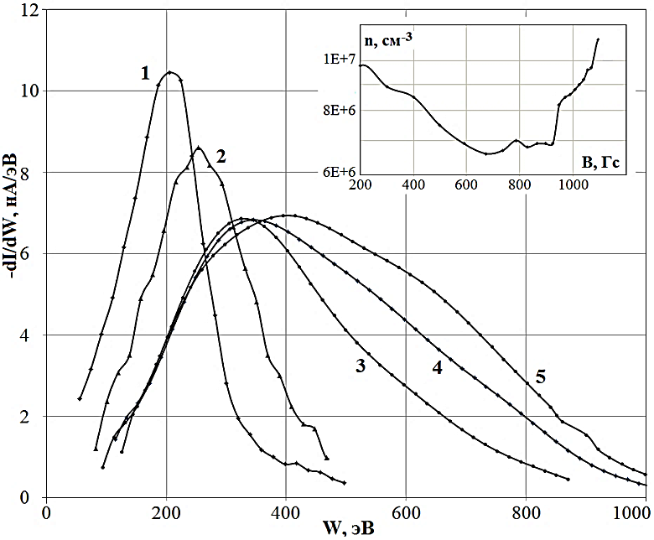
Along with this, the fact of a non-monotonic change in the position of the AL and the density of ions is reliably registered when the magnitude of the magnetic induction at the anode increases at constant pressure – fig. 2: the decrease in density is replaced when the field B ∼ 700 Gs on its growth.
Fig. 2. Evolution of the Е×В-discharge in argon with a change in the magnetic field at the anode: U_{p} = 1160 V; Р = 9⋅10^{–5} Torr; curve 1 – B = 100 G; 2 – 500; 3 – 970;
4 – 1070; 5 – 1140.
The report discusses the possible causes of these interesting events.
References
- Bardakov V.M., Kichigin G.N., Strokin N.A., Tech. Phys. Letters, 2010, 36, 185.
- Grishin S.D., Leskov L.V., Kozlov N.P. Plasma accelerators. Moscow: Mashinostroenie, 1983. 231 p.

