SPONTANEOUS inlet OF LITHIUM film AS A TRIGGER OF ITB EVENTS in experiments on CO+COUNTER, CO – AND CONTR - ECCD IN THE T-10 TOKAMAK
Pimenov I.S., Neudatchin S.V., Borschegovskiy A.A., Kislov A.Ya.
NRC "Kurchatov Institute ", Moscow, Russia, pimenowigor@mail.ru
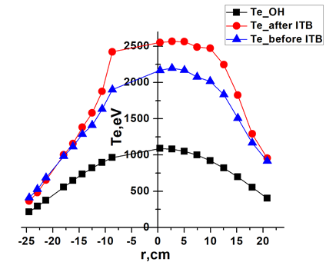
There are a large number of ITB event triggers (abrupt drop in heat and particle fluxes in the 30–60% of minor radius, first detected on the JT-60U tokamak, see details and references in [1], and
T-10 [2–3]). ITB events are accompanied by a bipolar perturbation of the electron temperature Te (simultaneous growth in the central and decay in the outer part of the plasma column). An example is experiments with the injection of C₈H₈ pellets on LHD [4] and deuterium pellets on T-10 [5], the drop of carbon flakes on TFTR [6] (in [5–6] shows the growth of T_{e} in the central part of the column and it is not clear whether there is an abrupt and non-local decline in heat and particle fluxes). This report provides examples of ITB events, the new trigger of which is the spontaneous flight of a lithium grain in different modes with the generation current of EC waves. The report describes the formation of the ITB in the plasmas with co+contr, co- and contr- ECCD. Simultaneously with the increase in density during the ionization of the lithium grain, there is a simultaneous growth of Te in the central (0.1 < r/a < ≈0.5) and a decline in the outer part of the column, the heat flux falls in the zone 0.1 < r/a < ≈0.7. The growth of Te lasts 15–20 ms or about the energy life time. The figure shows the change in the profile of Te(r) before and at the end of T_{e} growth. One can see the formation of ITB on both sides of the plasma column. However, the bipolarity of the T_{e} perturbation is not the only possible consequence. It was found in some pulses that the electron temperature decreases or remains at the same level. Apparently, ITB-events are observed not all shots with flying lithium grain. Further analysis of the experiments is carried out.

References
- Neudatchin S.V., Takizuka T., et al., Plasma Phys. Control. Fusion 44 A383-389 (2002).
- Neudatchin SV., Inagaki S, Itoh K., Kislov A.Ya. et al. 2004 J. Pl. and Fus. Res. Series 6 134.
- Neudatchin S.V, Shelukhin D.A., Mustafin N.A.2017 J. Phys.: Conf. Ser. 907 012015.
- Tamura N. et al., Ph. Plasmas 2005.
- Kapralov V.G. et al., Tech.Phys. Lett. 1995. Vol. 21. P. 57.
- M.W. Kissick et al., 1996 Nucl. Fusion 36 1691.

