Counter ion beams device for neutron generation based on inertial electrostatic confinement
Prokuratov I.A., Dulatov A.K., Lemeshko B.D., Mikhailov Yu.V.
Dukhov Automatics Research Institute, Federal State Unitary Enterprise, (VNIIA) bogolubov@vniia.ru
This article describes the counter ion beams inertial electrostatic confinement (IEC) device based on sealed-off neutron tube with two ion sources (Figure 1). Such system is used as neutron source.
The results of experimental investigations are presented in this article, they include studying of ion sources working regimes, discharge geometry, analysis of working regimes with different currents (0,2 ÷ 2 mA) and voltages (10 ÷ 80 kV), neutron yield measurements. Voltage rise leads to better discharge focusing. Working with currents higher than 1.5 mA shows change of discharge geometry in the main accelerated gap that leads to loss of discharge coaxiality. In experiments with deuterium steady state neutron yield was up to 3∙10⁵ neutrons/s (80 kV, 0.4 mA).
The second part of this article describes the method of neutron yield calculation which generalize the main features of IEC systems. Verification of this method was carried out for the wide range of different IEC devices with neutron yields 10⁴ ÷ 10⁸ neutrons/s. The verification shows good agreement of calculated values with experimental data. This method also used for analysis of possibility of neutron yield increasing in developed device.
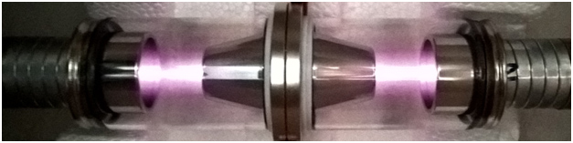
Figure 1 – Design of counter ion beams device while burning discharge on deuterium.

