Negative Hydrogen Ion Beam production and Transport
Sotnikov O.Z., Belchenko Yu.I., Deichuli P.P., Ivanov A.A., Sanin A.L.
Budker Institute of Nuclear Physics SB RAS, Novosibirsk, Russia, O.Z.Sotnikov@inp.nsk.su
High-voltage injector based on negative ion source is under development at Budker Institute of Nuclear Physics. Production and transport of negative ion beam are studied at separate test stand.
The stand consists of a negative ion source [2], a vacuum tank 3.1 m long and 2.1 m in diameter, vacuum pumps, two deflecting magnets that are used for 44 cm beam shift from the source axis, a Faraday Cup (FC) and beam calorimeter (BC), that is installed at the entrance of a single-aperture multielectrode 0.5–1 MeV accelerator. The use of the intermediate transport line to separate the negative ion beam from the accompanying particles, should reduce the load on the HV accelerator. Scheme of beam transport on the test stand is shown in figure 1.

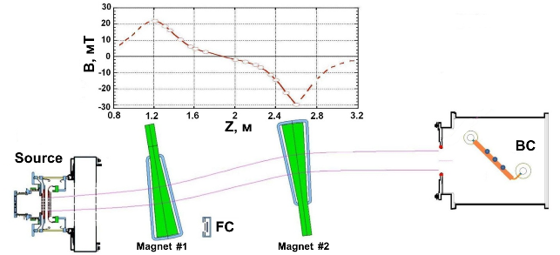
Figure 1. Beam transport scheme on experimental test stand: on the top, the distribution of the transverse magnetic field along the tank axis is shown.
The report describes the results of work on optimizing the parameters of the source and obtaining a negative ion beam with a current of 1 A, energy of 90 keV and its transportation through the transport line to the calorimeter installed at a distance of 3.5 m from the source. Also in the report will be presented and discussed the efficiency of beam transport depending on the parameters of the source and the transport line.
References
- Yu. Belchenko, A. Gorbovsky, A. Ivanov et al. AIP Conf. Proc. 1515, 167 (2013)
- Yu. Belchenko, A. Gorbovsky, A. Ivanov, et al. AIP Conf. Proc. 1655, 040002 (2015).

