OBTAINING OF LONG-LIVED PLASMA FORMATIONS WITH A HELP OF CAPILLARY DISCHARGES
Abakumov V.I., Bychkov V.L., Bikmukhametova A.R., Vaulin D.N., Safronenkov D.A., Chernikov V.A
M.V. Lomonosov Moscow State University, bychvl@gmail.com
The study of the formation of heterogeneous structures (up to 2 cm in diameter) of so-called long-lived plasma formations (LLO) in low-temperature plasmas is of considerable interest both from a point of view of elucidating the conditions and the thermodynamics of the formation of such structures under nonequilibrium conditions, and from a point of view of elucidation of their possible applications in plasma aerodynamics.
In this report, a study of heterogeneous luminous formations with a cladding under the action of an erosive plasma generator plasma jet on various materials has been carried out. Conditions were found out when the formation of objects whose lifetime reaches 2 seconds, with a shell and a vaporous nucleus took place. A dependence of the number of LLOs on the parameters of the installation was studied. Using an erosive plasma generator with an energy of the order of 190 J during ~ 10 ms inputted into the gas, experiments were carried out to obtain LLO on the basis of a tin-lead alloy, pure tin and pure lead. The conditions (the diameter of the plasma generator channel and the angle at which the jet is directed to the metal target) are clarified, under which several dozen LLOs arise.
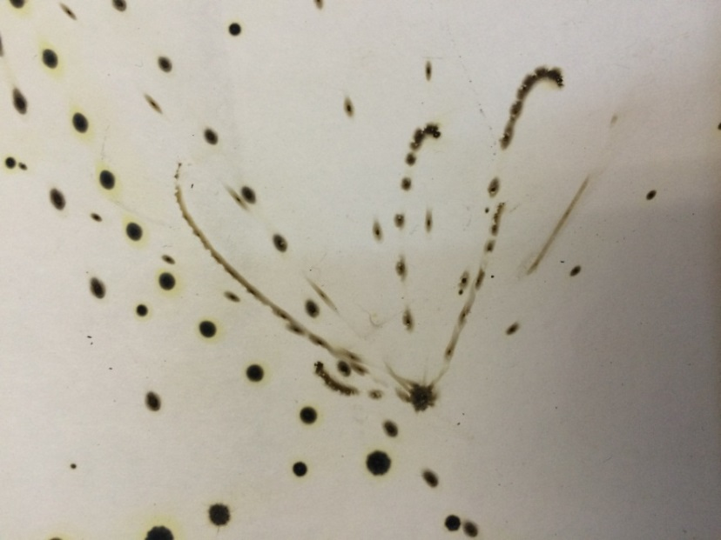
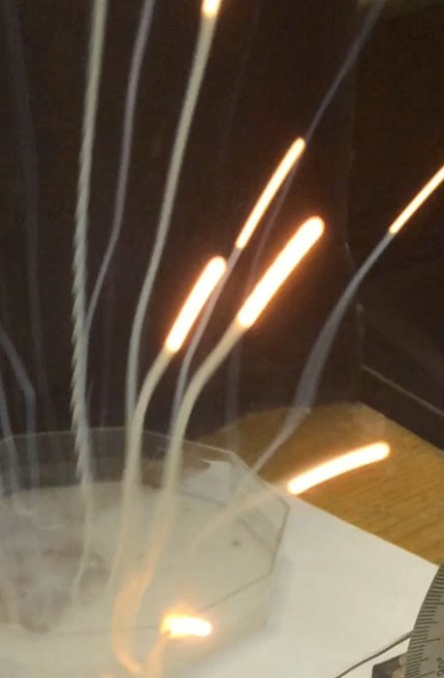
In Fig. 1. typical DPOs obtained in our experiments are presented. Figure 2 shows traces of melted droplets and exploding DPO. It is the presence of the envelope that makes it possible to explain explosions of LLO when it falls on a substrate.

Fig.1. Fig.2.

