PLASMA HEATING AND CURRENT GENERATION BEAM SYSTEM FOR FUSION NEUTRON SOURCE DEMO-TIN PROJECT
S.S. Anan’ev, E.D. Dlougach, A.I. Krylov, A.A. Panasenkov, A.Yu. Dnestrovskij, A.V. Klischenko, B.V. Kuteev
NRC Kurchatov Institute, Moscow, Russia, Ananyev_SS@nrcki.ru
For the fusion neutron source (FNS) steady-state operation is necessary heating and plasma current holing by power injection as neutral atoms beams. In the project DEMO-FNS will be used six injectors that provide additional heating power to 30 MW at energies of 500 Kev. Beam heating systems schematic location shown in figure 1a. As a prototype injector for the DEMO-FNS can be one of the injectors, developed for the ITER project that have the same current of neutral atoms with twice the power and energy of the beam [1]. Figure 1b shown neutral beam injector (without auxiliary systems) developed to NBI ITER. The report describes the concept of the system-neutral injection FNS, the composition of NBI, described in detail the design of the injector and the integration of NBI into the complex tokamak. Presented the results of beam path elements geometry optimization as well as systems for gas launching of NBI. Power profiles changing at the different distances from the ion source and the effect of the size of the output injection window on the power of the beam introduced into the plasma is described. Calculations of the fields created by the magnetic system of the installation and their effect on the operation of the elements of the NBI are given.
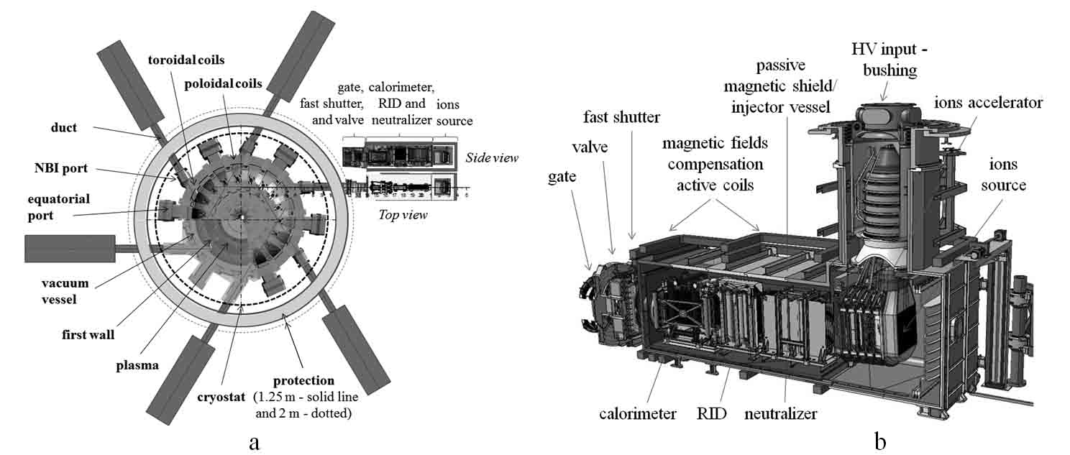
Figure 1. Beam heating systems DEMO-TIN schematic location - a and NB injector (without auxiliary systems and beam transporting to the plasma path) composition - b.

References
- S.S. Ananyev, A.V. Spitsyn, FC-FNS calculation code for hydrogen isotopes distribution modleing in fusion reactor fuel cycle systems // Problems Of Atomic Science And Technology, Fusion, 2017, v. 40, No. 1, p. 68-82

