SOLITARY WAVES IN HALL MAGNETOHYDRODYNAMICS
Savelyev V.V.
Keldysh Institute of Applied Mathematics, Moscow, RF, ssvvvv@rambler.ru
As it is known, in classical MHD is no dispersion of the waves. HMGD differs from MHD by "small" change in the Ohm's law – the view of the Hall effect [1,2]. This change gives HMGD one, at least, a new and important element – the dispersion of the waves. So it makes sense to look for solitary nonlinear waves, as is done, for example, for the KDV equation. In the present work this is implemented for the system of one-dimensional equations for a perfect HMGD and cold (it does not matter) plasma. As shown in the work, the question of the existence and properties of such waves reduces to the study of the following system of ODE-
(1)
Where x and y are – components of the magnetic field in the plane perpendicular to the wave direction, the R, Q are parameters. Solitary wave exists if in the system (1) there is a homoclinic phase curve. This is a curve that goes from a singular point (a saddle point), and then returns to the same point. Numerically it is shown that such curves exist. The figure shows an example of such a phase portrait and shows the distribution of the transverse components of the magnetic field in the wave.
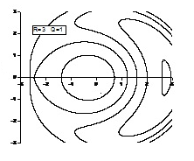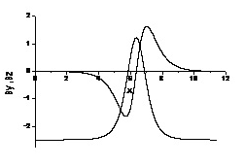

References
- Кадомцев Б.Б. , Коллективные явления в плазме, 2-е издание. М., Наука, Глав. редакция Физ.-Мат. Лит., 1988 (in Russian)
- Морозов А.И. , Введение в плазмодинамику, 2-издание, М., ФИЗМАТЛИТ, 2008 (in Russian)

