TO THE 90th ANNIVERSARY OF VLADISLAV BORISOVICH ROZANOV (1932-2019) *)
DOI: 10.34854/ICPAF.2022.49.1.008
Vergunova G.A.
Р.N. Lebedev Physical Institute of the Russian Academy of Sciences, Moscow, Russia, vergunovaga@lebedev.ru
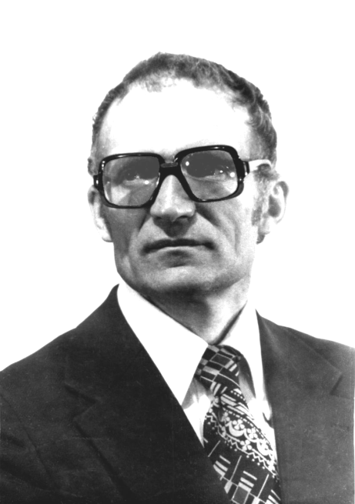
On December 11, 2022 Professor Vladislav Borisovich Rozanov would have turned 90. He was the outstanding Russian scientist in the field of nuclear and plasma physics and one of the founders of laser inertial confinement fusion theory.
After the graduation from the Physics Faculty of the Moscow State University in 1956, V.B.Rozanov and was sent to the Research Institute NII-1011 (now the RFNC-VNIITF named after academician E.I.Zababakhin, the town of Snezhinsk, Chelyabinsk region). From 1956 to 1966 he worked there on the Atomic Project of the USSR. Rozanov’s work during that period in the field of applied physics made a great contribution to the strengthening of country’s defense, and in 1966 he was awarded the Lenin Prize.
Since 1966 until the last days of his life, V.B. Rozanov has been working with P.N. Lebedev Physical Institute, at the Department of Quantum Radiophysics. He made a significant contribution to the physics of high-power lasers. He elaborated one of the first X-ray laser schemes based on pumping of active medium due to photo-ionization of electrons from the inner shells. The work of V.B.Rozanov on studying the emission spectra of gas discharges and the methods for their control formed the basis for the development of efficient pump sources for high-power lasers of various types. In 1981, these works were awarded the State Prize of the USSR.
V.B. Rozanov made a great contribution to the laser inertial confinement fusion (ICF) research and development. He actively participated in the creation of models of the main physical processes of ICF, and this formed the basis for the development of algorithms of mathematical programs for numerical simulation of compression and combustion of laser thermonuclear targets. This work was done in creative collaboration with scientists from Keldysh Institute of Applied Mathematics, RAS. Rozanov’s role in creating a modern concept of an ICF multilayer spherical shell target was decisive, as well as in studying the compression stability of such targets. V.B. Rozanov is the author of the evolutionary theory of hydrodynamic instabilities. He made a number of important proposals related to the concept of indirect compression of a thermonuclear target by a laser-induced X-ray pulse aimed at increasing the compression stability.
V.B. Rozanov contributed much to the development of a fusion-fission hybrid power reactor with controlled initiation of a nuclear reaction by thermonuclear neutrons.
For 40 years V.B. Rozanov has been lecturing at the Moscow Engineering Physics Institute, educating several generations of specialists in the field of high-temperature plasma and laser thermonuclear fusion. He was the author of several books and textbooks on plasma physics and inertial confinement fusion.

*) abstracts of this report in Russian

