MEASURING THE GAS TEMPERATURE of A MICROWAVE TORCH *)
DOI: 10.34854/ICPAF.2022.49.1.159
Davydov A.M., Artem’ev K.V.
Prokhorov General Physics Institute of the Russian Academy of Sciences
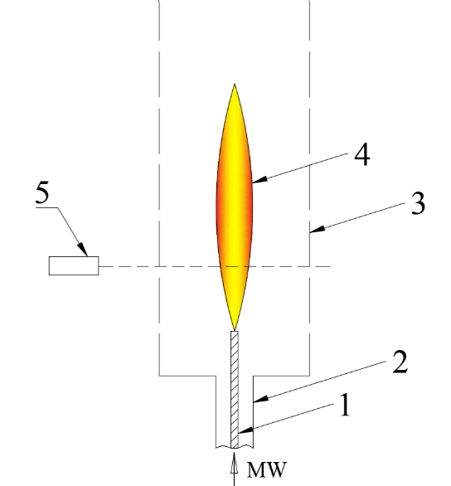
The results of an experiment on measuring the gas temperature in a microwave torch are presented. Its operation principle is described in [1]. A domestic magnetron (f = 2.46 GHz) was used as a source of microwave energy. The magnetron operated in a repetitively pulsed mode with a frequency of 50 Hz. The average microwave power deposited in the discharge was 550–600 W. The experimental setup is shown in the figure. The working gas (argon or air) was supplied through the hollow inner electrode. The coaxial section 2 was connected with the grid electrode 3 with cell dimensions 1×1 mm. The microwave discharge was initiated at the end of the inner electrode 1 where the maximum value of the microwave field. Then, during the microwave pulse an extended plasma formation 4 was formed. The emission spectra were recorded at various points of the discharge using an optical spectrometer 5. A continuous region of a spectrum in Wien coordinates was used to determine the gas temperature, assuming that the discharge is a Planck emitter. Thus, the axial temperature distribution of the discharge was obtained.

References
- S.I. Gritsinin, V.Yu. Knyazev, I.A. Kossyi, N.I. Malykh, and M.A. Misakyan. A Pulse-Periodic Torch in a Coaxial Waveguide: Formation Dynamics and Spatial Structure // Plasma Physics Reports, Vol. 30, No. 3, 2004, pp. 255–262. Translated from Fizika Plazmy, Vol. 30, No. 3, 2004, pp. 283–291.

*) abstracts of this report in Russian

