MEASUREMENT OF CHARACTERISTIC LIFETIME OF CATHODE SPOTS ARISING DURING EXCITATION OF MICROPLASMA DISCHARGE ON THE TITANIUM SURFACE COVERED WITH THIN OXIDE FILM *)
DOI: 10.34854/ICPAF.2022.49.1.151
Ivanov V.A., Konyzhev M.E., Kamolova T.I., Dorofeyuk A.A.
Prokhorov General Physics Institute, Russian Academy of Sciences, Moscow, Russia ivanov@fpl.gpi.ru
It is known that the flow of dense plasma in vacuum can initiate microplasma discharges (MDs) on the surface of a metal sample covered with a thin dielectric film [1]. These discharges result from an electric discharge (breakdown) between the outer surface of the film charged in the plasma flow and the open surface of the metal [2, 3].
The aim of this work was to study experimentally the spatial microstructure of the glow in the optical wavelength range using a high-speed IMACON468 photo recorder in frame mode, and to determine the lifetime of cathode spots during the propagation of a single pulsed MD excited on the surface of VT-1 titanium covered with a thin dielectric film with a thickness of up to 6 nm. MD was initiated on the titanium surface by a pulsed (25 μs) plasma flow with a maximum density of 2 × 10¹³ cm⁻³ and an electron temperature of 10 eV. At subsequent moments of time, the MD was supported by an external source of electric current and voltage (50 A, –400 V). The titanium sample was a grinded plate 20 × 20 × 0.6 mm³ in size. A dielectric oxide film with a thickness of up to 6 nm naturally formed on the titanium surface in atmospheric air at room temperature.
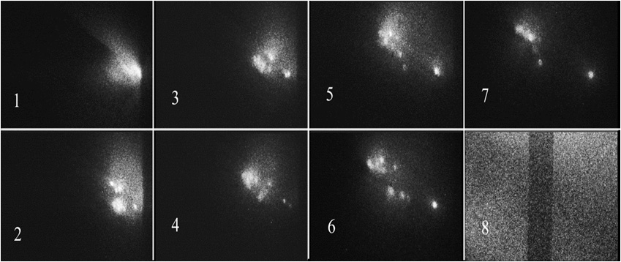
Fig. 1. Glow of a single microplasma discharge on the titanium surface, recorded in 7 consecutive frames (the duration of each frame is 100 ns, the interval between frames is 500 ns). Frame No. 8 is the calibrated frame (the width of the dark vertical strip is 1 mm). The size of each frame is 7×6 mm². The plasma flow moves from the plasma injector to the titanium plate from the right side.
Based on the analysis of microplasma discharge images (Fig. 1), it was found that the glow of a microplasma discharge on the titanium surface covered with a 6 nm oxide film visually at a microscale consists of 4–10 simultaneously brightly glowing “point” formations – cathode spots, the characteristic lifetime of which is about 1 μs.
References
- Ivanov V.A., Sakharov A.S., Konyzhev M.E., Plasma Physics Reports, 2008, V. 34, No. 2, Pp. 150–161.
- Ivanov V.A., Sakharov A.S., Konyzhev M.E. et al., Journal of Physics: Conference Series 907 (2017) 012023 https://iopscience.iop.org/article/10.1088/1742-6596/907/1/012023/pdf
- Ivanov V. A., Konyzhev M. E., Dorofeyuk A. A. et al., Journal of Physics: Conference Series 1647 (2020) 012018 https://iopscience.iop.org/article/10.1088/1742-6596/1647/1/012018/pdf

*) abstracts of this report in Russian

