OPTICAL SPECTROSCOPY OF EROSION PLASMA JETS OF A DC PLASMA Torch in the nucleation zone of a copper / graphene nanocomposite *)
DOI: 10.34854/ICPAF.2022.49.1.128
Shavelkina M B., Каvyrshin D.I.
Joint Institute for High Temperatures of Russian Academy of Sciences, Moscow, Russia, mshavelkina@gmail.com
The aim of this work is to study by optical methods the intercalation process during the synthesis of 3D graphene nanostructures in plasma jets of helium generated by a DC plasma torch.
The synthesis of the copper-containing nanocomposite was carried out with a decrease in the flow rate of the plasma-forming gas to a certain threshold value [1], at which the plasma column caused the ultimate erosion of the outer surface of the copper nozzle anode. To study the parameters of the erosion plasma jet and the processes occurring in it, a three-channel fiber-optic spectrometer AvaSpec 2048 was used, which records plasma radiation in the spectral range of 220–1000 nm with a spectral resolution of 0.2–0.5 nm [2]. Figure 1 shows the determination of the temperature of the solid phase from its thermal radiation by the method of Wien coordinates [3]. The calculated temperature was 1700 K.

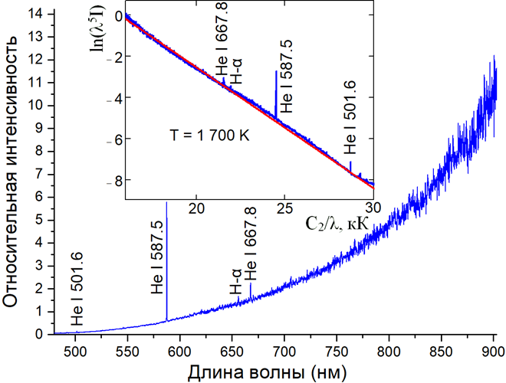
Figure 1. The determination of the temperature of the solid phase by the Wien coordinates method.
In general, the possibility of using copper as a graphene intercalate in the creation of 3D nanostructures under plasma conditions has been shown. It was found that at a temperature of 1700 K, the maximum spectral flux density of the solid phase formed by condensed carbon (C2) is reached.
The work is supported by the Russian Foundation for Basic Research, grant nos. № 20-58-04013 Бел_мол_а.
References
- Шавелкина М.Б. и др. ХВЭ, 2019, 53, 380.
- Shavelkina M B. et al. High Temperature, 2020, 58, 309.
- Ochkin V N Weinheim: Wiley-VCH, Chichester, 2009.

*) abstracts of this report in Russian

