Investigation of the power factor of a microwave pulse of gyrotron radiation in mixtures of Al₂o₃ / Pt powders *)
DOI: 10.34854/ICPAF.2022.49.1.154
Zakletskii Z.A., Malakhov D.V., Skvortsova N.N., Borzosekov V.D., Stepakhin V.D., Gusein-zade N.G.
Prokhorov General Physics Intstitute of the Russian Academy of Science, ngus@mail.ru
For plasma-chemical interactions between particles in a mixture of powders, it is important to match the parameters of the microwave pulse of the gyrotron, the particle size and the mass ratio of the components in the initial powder metal-dielectric mixture. Changes in the absorption coefficient of microwave radiation in a metal-dielectric powder mixture can serve as a qualitative characteristic for analyzing the processes occurring in a plasma-chemical reactor.
To determine the absorption coefficient, microwave diagnostics is used based on 3 microwave sensors (Fig. 1). The power of gyrotron radiation absorbed in the powder can be calculated from the balance relation Pabs = Pin - Pref - Ppas, where Pin is the radiation power entering the plasma-chemical reactor, Pref is the radiation power reflected from parts of the quasi-optical path and elements of the plasma-chemical reactor, Ppas is the transmitted radiation power. through a plasma-chemical reactor. The absorption coefficient is the ratio K = Pabs / P in.
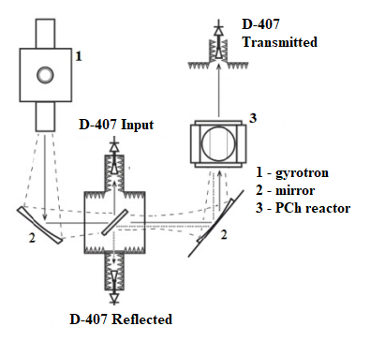
Figure 1 - Schematic diagram of the determination of the absorption coefficient of the absolute power of the microwave pulse of the gyrotron
The work was carried out within the framework of the state assignment GZ BV10–2021 "Study of the innovative synthesis of micro- and nanoparticles with a controlled composition and structure based on a microwave discharge in gyrotron radiation".

*) abstracts of this report in Russian

