Detection of super-energetic electrons in a high-current REB generator *)
DOI: 10.34854/ICPAF.2022.49.1.133
Belozerov O.S., Bakshaev Y.L., Khromov S.A., Dan’ko S.A.
NRC "Kurchatov Institute", Moscow, Russia, Belozerov_OS@nrcki.ru
In pulsed high-current generators of relativistic electron beams, acting on a load transparent to them, there is a phenomenon of ion acceleration. The energy of individual ion bunches can be several times higher than the applied voltage of the pulse generator multiplied by the ionic charge. As part of research on ion acceleration, experiments were carried out on the Katran generator (pulse voltage ~ 250 kV, current 50 - 150 kA, pulse duration ~ 60 ns) [1], which showed that ion acceleration occurs in two places: inside high voltage generator diode and outside behind a thin anode foil. It is most likely that the acceleration of ions to ~ 850 keV/nucleon in the cathode-anode gap is associated with pinching or a rupture of the current channel, which leads to the appearance of a strong vortex electric field. Electrons in such a field should acquire significantly higher energy than the potential difference of the high-voltage diode multiplied by the charge.
This paper presents an experimental measurement of the energy of electrons by bremsstrahlung gamma radiation. To determine the electron energy, it used the filter method, which compared the ratio of the gamma-ray bremsstrahlung signals from the open sensor to the sensor signal behind the filter with the same ratio calculated by the Kramers' law [2]:
N_{λ} = CZ(λ-λ₀)/(λ₀λ²) (1)
where N_{λ} is the number of photons per unit time per unit surface of a massive sample, C is a constant depending on the target material, λ₀ is the minimum radiation wavelength corresponding to the energy of the emitting electron.
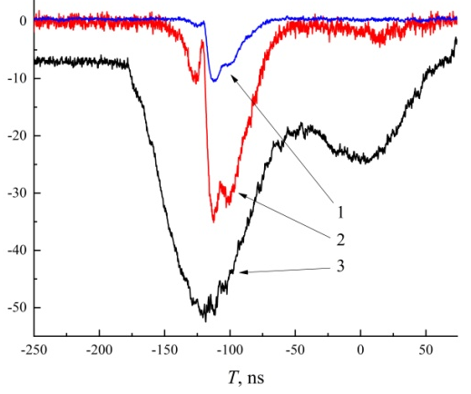
In fig. 1 shows the voltage signals of the generator and the used SKD1-01 silicon detectors behind a 6 mm lead filter and SKD1-02 without a filter.
Since the time resolution of the SKD1-01 and SKD1-02 detectors is 3.5 and 5 ns, respectively, the characteristic frequency of current oscillations arising in a high-voltage diode during electron beam generation is 0.5 GHz, the detector signals reflect the average value of the electron energy. Only a small fraction of the electrons are super-energetic since the phase of the ultrahigh vortex field is short. And even under this condition, the measured signal ratio is consistent with that calculated for electrons with an average energy of ~ 400 keV.
Fig. 1. Typical signals:
(1) - SKD1 01 with filter, rel. units;
(2) - SKD1 02 without filter, rel. units;
(3) - generator transmission line voltage, kV/5
This work was supported by the National Research Center "Kurchatov Institute" (order No. 2073 dated 09.10.2020).
References
- O.S. Belozerov, S.A. Dan’ko and Khromov S.A. Problems of Atomic Science and Technology, series “Thermonuclear Fusion”, 2021. Vol. 44, No. 1, p. 136-144. (in Russian)
- Pavlinsky G.V. Fundamentals of X-ray physics. - M .: Fizmatlit, 2007. - 240 p. (in Russian)

*) abstracts of this report in Russian

