Ectons and spontaneous and forced transitions in plasma relativistic microwave sources *)
DOI: 10.34854/ICPAF.2022.49.1.153
Ivanov I.E.
Prokhorov General Physics Institute of the Russian Academy of Sciences, Moscow, Russian Federation, iei@fpl.gpi.ru
In plasma relativistic electronics, the occurrence of microwave radiation is explained by the beam-plasma interaction, i.e. self-consistent action of the beam on the plasma and plasma on the beam [1]. Such a mechanism requires a multi-pass wave mode in the interaction space. Experimental results of the operation of plasma relativistic microwave sources (PRMS) indicate the existence of a single-pass regime. In fig. 1 shows the spectra of two radiation oscillograms obtained under the same conditions, but in case (b) a monochromatic magnetron signal at a frequency of 2.7 GHz was fed to the input, and in case (a) it was not.
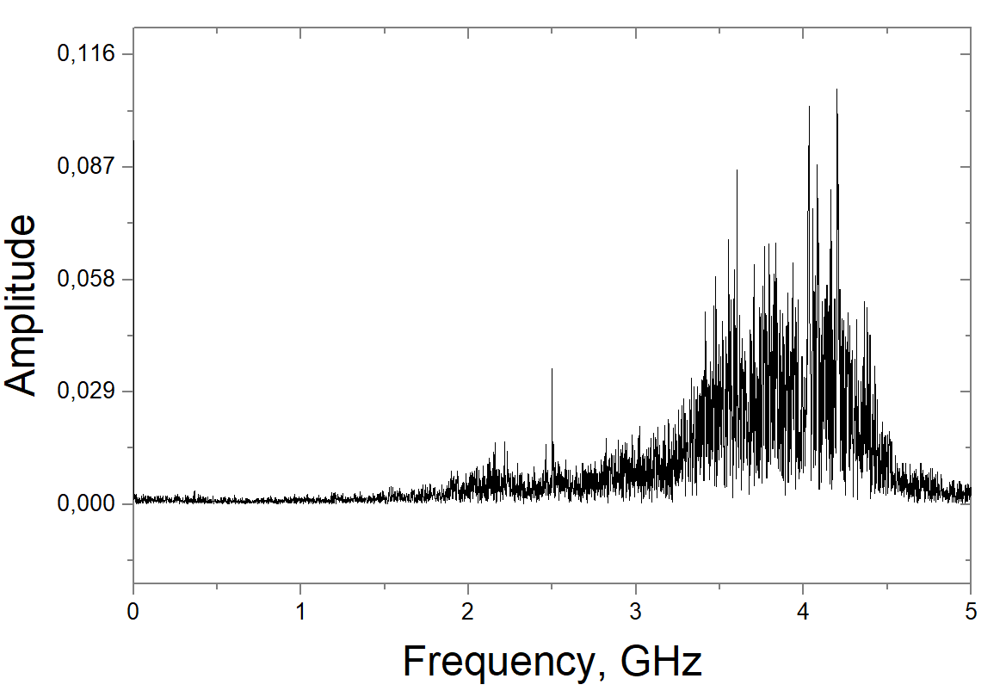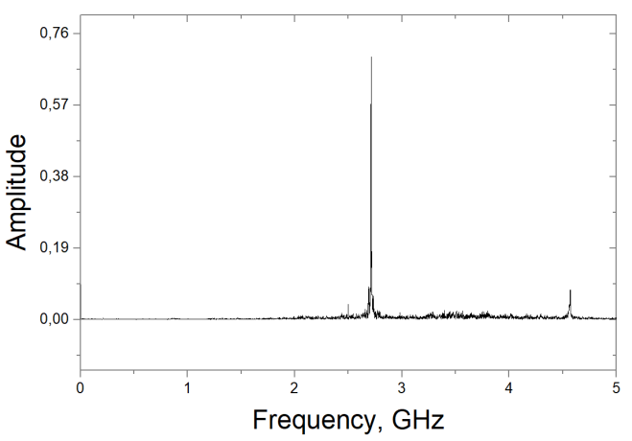
(a)
(b)
Fig. 1. (a) - emission spectrum without an input signal (noise generation); (b) - emission spectrum, when the driving signal of the magnetron is applied to the input (amplification of the external monochromatic signal). The plasma density in the system is the same.
Spontaneous emission (a) is replaced by stimulated emission (b). This behavior is typical for lasers in the optical range, whose operation is based on the creation of an inverted population of energy levels, the processes of excitation and relaxation are separated in time, and single-pass lasing modes are possible.
In the present work, we consider the emission of PRMS as a result of spontaneous and forced transitions in a plasma waveguide, the plasma of which is polarized by a relativistic beam. A relativistic electron beam (REB) is represented by irregular electron bunches formed at the cathode of a relativistic beam due to explosive emission, which were previously called ectons [2]. Microwave pulses have an energy of 15 - 20 J with a duration of 300 - 500 ns, an REB pulse duration of 700 ns, and a beam current of 2.5 kA. To explain this result, the classical formula of the Vavilov-Cherenkov effect [3] is considered as applied to microwave radiation with radiation frequencies of 2 - 4 GHz and a plasma density of 3 × 10¹² cm⁻³.
The work was carried out within the framework of the RFBR project 19-08-00625 A.
References
- Kuzelev M.V., Rukhadze A.A., Strelkov P.S. Plasma relativistic microwave electronics. M .: LENAND, 2018.
- Mesyats G.A. Pulse power engineering and electronics. M.: Nauka, 2004
- Tamm I.E., Frank I.M. // DAN SSSR 14 (3), 107 (1937).

*) abstracts of this report in Russian

