ELECTRODYNAMIC CHARACTERISTICS AND MICROWAVE FIELD STRUCTURE OF A RESONANCE DISCHARGE IN A minimum-B magnetic mirror *)
DOI: 10.34854/ICPAF.2022.49.1.146
³Dvinin S.А., ^{1,2}Korneeva M.A.
¹RUDN University, korneevama@mail.ru,
²Federal State Institution «Scientific Research Institute for System Analysis» of the Russian
Academy of Sciences
³Lomonosov Moscow State university, s_dvinin@mail.ru
The paper presents the results of numerical and analytical calculations of the microwave field structure and the distribution of the absorbed microwave power in a cylindrical resonator placed in a minimum-B magnetic mirror. The resonator is excited through a slit in the sidewall (Fig. 1). The dependence of the discharge impedance on the concentration of electrons is calculated (Fig. 2). The cyclotron resonance conditions (ω=Ω_{e}) are satisfied in the central region of the resonator for the microwave field ω/2π=2.45 GHz. These discharges are interesting in the development for sources of ion beams and plasma-chemical reactors [1].
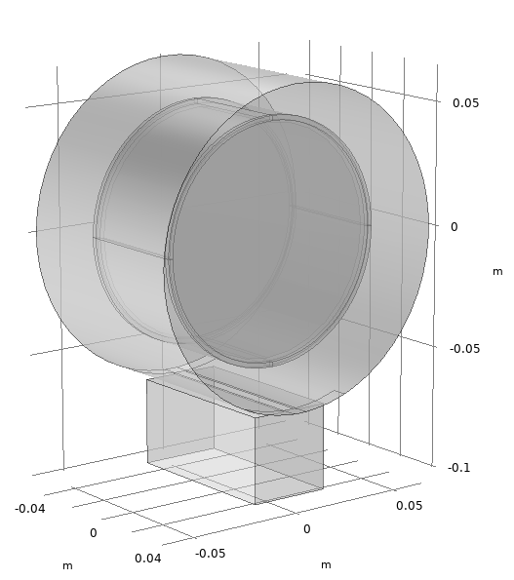  Fig. 1. Geometric model of the resonator | 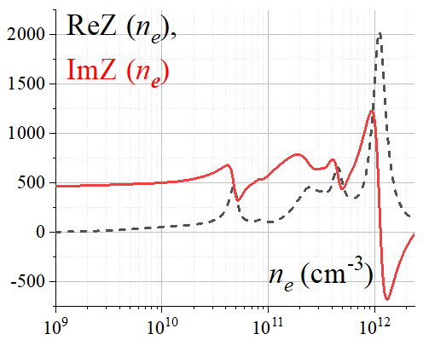  Fig. 2. Change in the impedance of the resonator when the electron density changes
The density of electrons in the discharge at low pressures (10^{–4} Torr) is significantly lower than the critical density (n_{c}=mω²/4πe²). Therefore, the absorption of the electromagnetic wave occurs in the region of cyclotron resonance. An increase in gas pressure is accompanied by a significant increase in the electron density up to 3⋅10¹¹ cm^{–3} [2] and a qualitative restructuring of the spatial distribution of the electromagnetic field. Experimental measurements of wave polarization with high-frequency probes confirm this.
Numerical simulation with the Comsol Multiphysics® (the license belongs to the Faculty of Physics of Moscow State University) showed that there are several absorption bursts at certain electron densities on the impedance dependence of a plasma-filled resonator (Fig. 2). A qualitative restructuring of the electromagnetic field occurs in the interval between bursts, which is consistent with the results of the experiment.
References
- G. Castro, D. Mascali, S. Gammino, G. Torrisi, F. P. Romano, L. Celona, C. Altana, C. Caliri, N. Gambino, D. Lanaia, R. Miracoli, L. Neri и G. Sorbello // Plasma Sources Sci. Technol., 26, 2017, 055019.
- V.V. Andreev, I. A. Voldiner, M.A. Korneeva // Plasma Physics Reports, 43, 2017, 1119.

*) abstracts of this report in Russian

