MEASURING THE PLASMA FLOW RATE OF THE QSPU BY THE DOPPLER EFFECT *)
DOI: 10.34854/ICPAF.2022.49.1.126
Yaroshevskaya A.D., Malyutin A.Yu., Podkovyrov V.L., Gutorov K.M., Kartasheva A.A.
«TRINITI JSC», YaroschAD@triniti.ru
The development of a new type of electric rocket engine (ERE) with increased thrust and specific impulse parameters is carried out on the basis of a quasi-stationary plasma accelerator (QSPU) [1], which must operate in a pulse-periodic mode. To study the parameters of the ERE flow, a diagnostic complex was created, one of the components of which was a system for determining the plasma flow rate with a time resolution, which makes it possible to track the change in the flow rate during the discharge pulse.
The used velocity diagnostics is based on the change in the wavelength of the emission line of atoms in the plasma flow due to the Doppler effect. The radiation collected in three directions of observation from one point in space was reduced to one matrix: towards, perpendicular and after the flow. The method was implemented on the basis of an M522i monochromator and a PHANTOM 2640 high-speed video camera. The radiation was collected by optical fibers with collimators placed directly in the vacuum chamber. The effect was observed at the 587.56 nm helium line. With a total plasma glow duration of 2.0 ms, the equipment used makes it possible to obtain an object velocity value every 10 μs.
In fig. 1 shows the results of applying the method to helium plasma flows, as well as hydrogen and deuterium plasma with a 10% helium impurity content (diagnostic marker). The developed method makes it possible to measure the velocity of plasma flows with a frequency of 10⁵ frames / s for any gas with the addition of helium. In the course of the experiments, the characteristic features of the behavior of the QSPA plasma flow were revealed depending on the type of plasma-forming gas and the energy deposited into the discharge.
These studies were made as a part of government contract No. Н.4ts.241.09.21.1115 dated April 29, 2021.
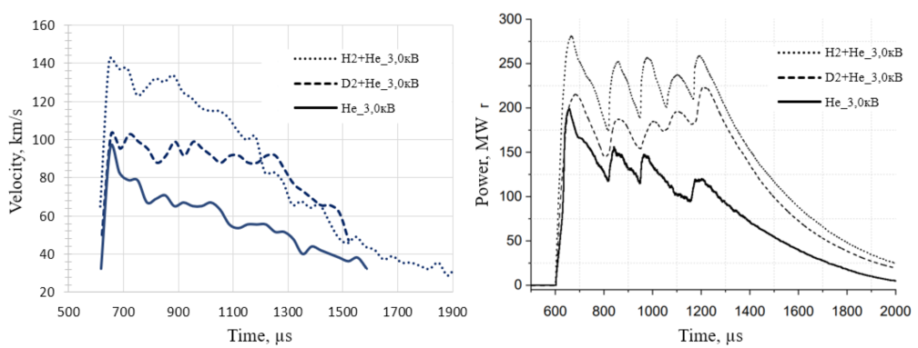
Fig. 1 ¬ Dynamics of the plasma flow velocity and instantaneous power of the QSPU discharge
References
- N.S. Klimov., Et al., "Experimental study of the integral characteristics of the plasma flow and discharge of a quasi-stationary high-current plasma accelerator with its own magnetic field" VANT. Ser. Thermonuclear fusion, 2019, vol. 42, no. 3.

*) abstracts of this report in Russian

