EXPERIMENTAL DATA PROCESSING SYSTEM FOR ESTIMATING THE PLASMA FLOW SPEED BY THE METHOD BASED ON THE DOPPLER EFFECT *)
DOI: 10.34854/ICPAF.2022.49.1.125
Maliutin A.Y., Yaroshewskaya A.D., Podkovyrov V.L., Gutorov K.M.
JSC “SRC RF TRINITI”, maliutin@triniti.ru
The KSPU-T plasma accelerator is used to perform experiments to create an electrical jet engine with increased propulsion and impulse parameters. For such studies it is important to measure mechanical parameters of plasma flow like density, velocity, impulse. These measurements are carried out using diagnostics consisting of a complex of spectral and optical devices.
The measurement of the plasma velocity using Doppler effect is based on simultaneous observation of the luminescence spectrum of the flow section in opposite and direct way. It was found that helium spectrum (line at wavelength of 587.56 nm) is the most convenient for registration and further processing. In case of accelerator operation with hydrogen or deuterium, helium is added to plasma-forming gas as indicator impurity (about 10 %).
The following set of devices is used to record plasma luminescence. Light guides are interested in to vacuum vessel of accelerator and connected to a spectrograph-monochromator which decompress the guides radiation to the spectrum and projects it to the matrix of the high-speed camera. Image frame rate of this diagnostic is up to 100000 frames per second. Obtained image sequence contains spectral lines shifted by the Doppler effect. Shift distance of this lines is proportional to plasma flow speed. For example, Figure 1 shows the resulting frames at the moment of the beginning of acceleration (А), the steady-state mode (Б) and the moment of speed decay and flow extinction (В, Г). The frames may contain low intensity lines, noise, and side lines due the presence of standing gas in the volume of vacuum vessel. It makes image processing and speed calculation difficult. Each pulse produces about 50 frames that require analisys.
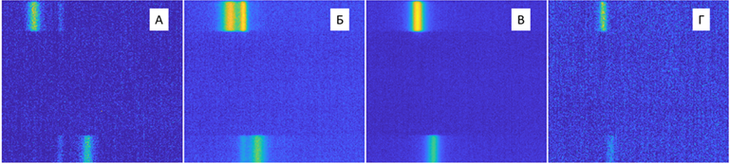
Figure 1 – Frames with registered spectral lines
Processing algorithm has been implemented in the MATLAB environment for automated analysis of frame sequences. The algorithm allows to calculate the plasma velocity from the shift of spectral lines and obtain the dependence of the velocity on the discharge time. The algorithm has built-in functions for calibrating the system by reference radiation, filtering spectra and eliminating side effect lines. The user interface of the compiled MATLAB application allows to interactively process sequences of frames and single images for detailed analysis, as well as save the calculation results in the form of graphs and tabular values.
These studies were made as a part of government contract No. Н.4ts.241.09.21.1115 dated April 29, 2021.

*) abstracts of this report in Russian

