INVESTIGATION OF GENERATION OF SOFT X-RAY RADIATION IN THE RANGE OF WATER TRANSPARENCY IN A NANOSECOND PULSE DISCHARGE PLASMA *)
DOI: 10.34854/ICPAF.2022.49.1.113
^{1,2}Samokhvalov A.A., ²Sergushichev K.A., ^{1,3}Eliseev S.I., ²Smirnov A.A., ²Bronzov T.P., ²Getman D.V., ²Bolshakov E.P., ²Burtsev V.A.
¹ITMO University, St. Petersburg, Russia
²Burtsev Laboratory Limited Company, St. Petersburg, Russia
³St. Petersburg State University, St. Petersburg, Russia
Soft X-ray radiation (SXR) in the region of water transparency, i.e. in the wavelength range of 2.3-4.4 nm, is of interest for microscopy of biological objects, since allows obtaining images in the transmission mode of thick layers (~ 10 µm) of cell cultures with a resolution of up to 7 nm [1]. The sources of this radiation are synchrotrons, laser plasma, and plasma of a nanosecond pulsed discharge. The latter has several advantages, it is the possibility of obtaining SXR pulses of high spectral brightness and low divergence, the compactness of installations for obtaining it and the ability to work with pulse repetition rates of more than 5 kHz [2]. In this work, we investigated the generation of SXR in a capillary plasma of a nanosecond pulsed discharge to obtain the maximum SXR yield in the water transparency range.
The experiments were carried out on a setup developed at BurtsevLab LC. The discharge geometry was a hollow cathode, gas was continuously blown through a capillary (length 20 mm, inner diameter 1.5 mm). A high-voltage pulse of negative polarity with an amplitude of 16-30 kV was fed to the cathode. Carbon dioxide was chosen as the working gas, because the transitions of highly excited carbon ions emit in the range of 3-4 nm. Figure 1 shows the results of the experiments.
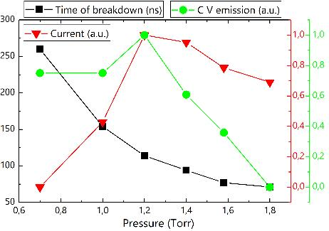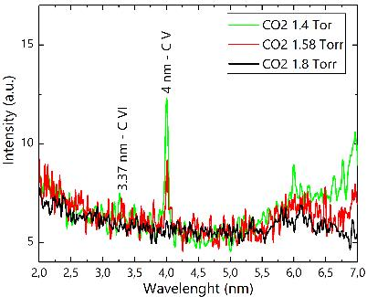
Рисунок 1. Зависимости времени пробоя от давления, амплитуды тока и интенсивности излучения линии иона C V и спектры излучения плазмы разряда (справа).
The results indicate the coincidence of the maximums of the current and the intensity of SXR at a certain value of the gas pressure. This is explained by the dependence of the effective plasma resistance on pressure; at low values, the breakdown time increases and the energy input to the plasma is low; the current drop with a further increase in pressure is associated with a decrease in the amplitude of the breakdown voltage from the gas pressure.
The study was supported by a grant the Russian Science Foundation (project No. 21-79-10110).
References
- B. Rösner et. al., Optica, 2020, 7, 1608.
- K. Bergmann et. al. Appl. Opt., 2000, 39, 3833.

*) abstracts of this report in Russian

