Determination of plasma parameters from relative intensities of Ar XVII lines using greed search method *)
DOI: 10.34854/ICPAF.2022.49.1.079
Baronova Е.О.
National Research Center “Kurchatov institute”, Moscow, Russia, baronova04@mail.ru
Relative intensities of helium like lines are widely used to estimate plasma electron temperature and density. Tokamaks, plasma focuses, stellarators, etc are usually filled by deuterium with a small amount of higher z gas (neon, argon, xenon, etc) used for diagnostics. Diagnostic gas is ionized during the discharge and the higher is its atomic number – the higher electron temperature is required to ionize it up to helium like state so that the hoter plasma region can be studied. For example Ar XVII ions are presented in plasma with electron temperature 400-3000 eV, which is inherent to the modern installations aimed to study possibilities of realization of thermonuclear fusion.
Method of plasma parameters estimation is based on the comparison of calculated spectra with the spectra registered in experiment. Typically, the parameters estimation is performed manually. Firstly, choose hypothetic values for the plasma parameters, calculate the corresponding plasma spectra, then compare the plots for the calculated spectra and the spectra registered in experiment visually. Finally, the procedure is repeated for a different values set. Such a process is time taking and it is not always possible to achieve a good match.
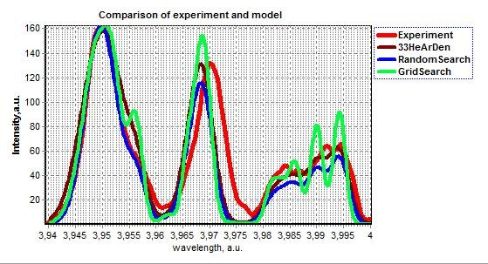
In present paper we introduce the numerical code which automates the selection of plasma parameters. The new module extends the existing module of intensities calculation given plasma parameters with estimation of plasma parameters based on grid search and random search methods. The estimation is performed by minimizing squared deviation of intensities for control wavelengths, which subjectively corresponds to the visual similarity of the spectra graphs. Spectra of Ar XVII is shown in fig. 1 registered from plasma focus discharge (red curve) with the current 500 kA. Numerically calculated ArXVII spectra for parameters obtained by manual search (brown curve), by grid search (green curve) and by random search (blue curve) methods are likewise shown in fig.1.
Application of code permits one to reduce the plasma parameters search time by two orders of magnitude. The proposed technique is particularly relevant if the results are needed to be quickly processed during the experiments. We are planning to further develop algorithms of the numerical code including the development of the interface convenient for experimentalists.

*) abstracts of this report in Russian

