Compact torus (FRC) COLLIDER *)
DOI: 10.34854/ICPAF.2022.49.1.081
^{1,2}Mozgovoy A.G.
¹P.N. Lebedev Physical Institute, Russian Academy of Sciences, Moscow, Russia
²Know How Ltd, Moscow, Russia, mozgovoy@lebedev.ru
A compact torus, or FRC (Field Reversed Configuration) is an axisymmetric configuration with a closed loop with a current in the plasma. The main advantage of such torus is the possibility of their acceleration and compression by an external magnetic field for use in inertial thermonuclear fusion, as well as in electric rocket thrusters or for collective ion acceleration. The main idea of a FRC collider in the formation of two torus with their subsequent acceleration towards each other.
Compact torus were obtained using theta-pinches at the Novosibirsk BINP, later at TRINITI, and the Sukhum Physicotechnical Institute. In the USA - in Livermore, Los Alamos. Currently, two private companies Tri Alpha Energy (rised 800 mil. $.+50 mil. $ from Rosnano) and Helion Energy (recieved 500 mil. $ in 2021) are conducting research on ICF using FRC. Their method of forming FRCs using theta-pinch is not effective - the current in a compact torus is always small, but it is promised to supply energy to the grid by 2024.
We have proposed a new method for formation of compact torus in inductive storage devices [1]. The energy of the magnetic field was accumulated in two inductors in the form of multi-start windings, such as an Archimedes spiral, placed on the end flanges of the vacuum chamber. Before the current maximum, plasma was injected into this volume and the current was forcibly cut off with exploding wires. When the current is cut off, a closed current loop arises in the plasma, capturing most of the magnetic flux (more than 70 percent) and storing the energy stored in the magnetic field. Two formed FRC with the same current direction begin to attract each other. When they collide, the plasma heats up and to flash of soft X-ray.
Seven independent capacitor banks and switches were used (a total of 60 capacitors, K-5-40, charging voltage 20-26 kV, energy storage up to 100 kJ)
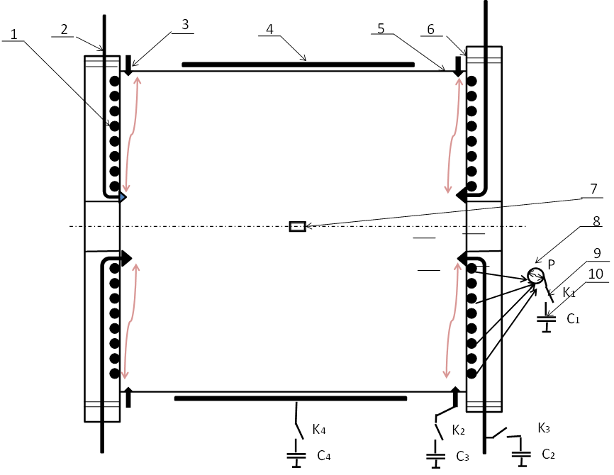
The current in the FRC, according to estimates, reached several tens of kiloamperes with a diameter of 30 cm. The plasma temperature at the collision site exceeded several keV and the duration of a soft X-ray pulse was about 1 microsecond, i.e. three orders of magnitude higher than in installations with a plasma focus and with a Z-pinch. 1 - inductive storage in the form of a 3-lead spiral, 2 - high-voltage electrodes (to create an azimuthal magnetic field), 3 - plasma guns, 4 - loops for radial plasma compression, 5 - vacuum chamber with a diameter of 300 mm, 6 - end flanges with inductive storage devices, 7 - magnetic field sensor in the center of the chamber, 8 - current breaker on exploding wires, 9 - K1-K4 switches (half shown) 10 - C1-C4 capacitor banks (half shown)
References
- A.G. Mozgovoy, I.V. Romadanov, and S.V. Ryzhkov, Formation of a compact toroid for enhanced efficiency, Phys. Plasmas 21, 022501 (2014).

*) abstracts of this report in Russian

