STUDY OF THE PHASE COMPOSITION OF the PRODUCTS of ELECTRIC EXPLOSION OF THIN METAL CONDUCTORS BY THE METHOD OF TWO-WAVELENGTH LASER probING *)
DOI: 10.34854/ICPAF.2022.49.1.084
Romanova V.M., Tilikin I.N., Ter-Oganesyan A.E., Mingaleev A.R., Shelkovenko T.A., Pikuz S.A.
P.N. Lebedev Physical Institute of the Russian Academy of Sciences, Moscow, Russia, romanovavm@lebedev.ru
Studies of the electrical explosion of thin metal wires in air and in vacuum using laser probing at two wavelengths (λ₁ = 1064 nm and λ₂ = 532 nm) have shown that the scenario of the process can radically differ from the widespread one. The process of wire explosion is often associated almost exclusively with rapid evaporation metal and with the subsequent breakdown of the formed steam. Wherein, the main mechanism of attenuation of transmission radiation in explosion products is considered to be absorption or refraction at the density boundaries. In the presented experiments on the explosion of micron wires in vacuum and in air, with an increase in the probe wavelength, a significant increase in the transparency of the object under study was observed, which can only be due to the scattering of probe radiation [1, 2]. As a result, it was proved that the explosion products not only consist of a vapor of wire material, as previously assumed by many authors, but also contain a significant amount of small, less than one hundred nanometers, particles, the scattering of which obeys the Rayleigh dependence on the wavelength (~ λ^{–4}). A finely dispersed medium can have a significant effect on the results of interferometric measurements. Multiple scattering of a laser beam as it passes through a substance containing micron-sized particles leads to a partial or complete loss of radiation coherence, which inevitably affects the quality of the resulting interference pattern. The contrast of the bands in the presence of this effect can decrease until they disappear. To avoid an erroneous interpretation of the results obtained, the scattering factor must be taken into account in studies on the electric explosion of thin wires.
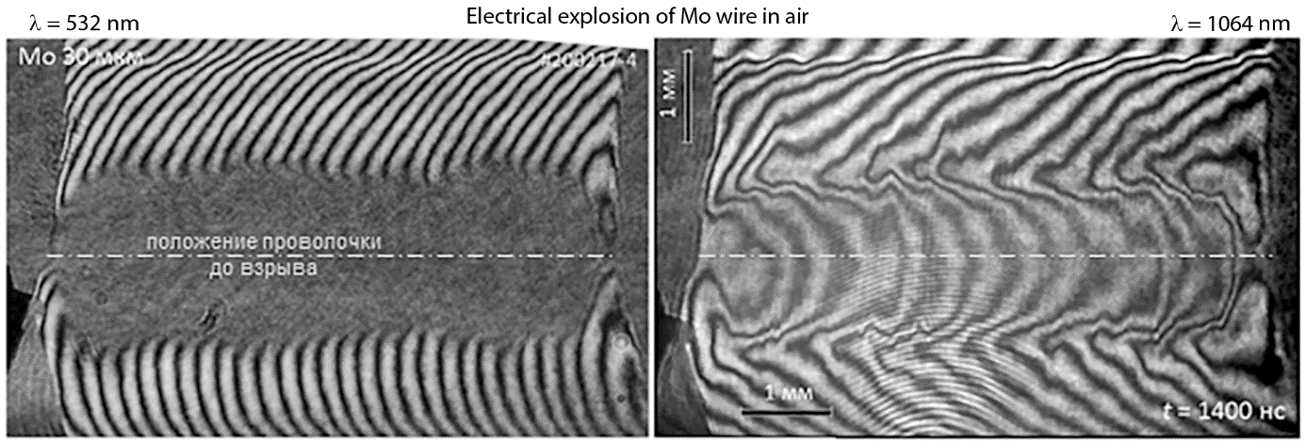
References
- V.M. Romanova, G.V. Ivanenkov, E.V. Parkevich et al., Laser scattering by submicron droplets formed during the electrical explosion of thin metal wires. J. Phys. D: Appl. Phys., Vol. 54, 175201 (2021).
- V.M. Romanova, I.N. Tilikin, A.R. Mingaleev et al., Plasma Phys. Rep., Vol. 48, No. 2 (2022) (in press).

*) abstracts of this report in Russian

