Status of HIGH-VOLTage NEUTRAL beam INJECTOR WITH ACCELERATION OF NEGATIVE HYDROGEN IONS *)
DOI: 10.34854/ICPAF.2022.49.1.170
Sotnikov O.Z., Belchenko Yu.I., Ivanov A.A., Sanin A.L., Gorbovskii A.I.
Budker Institute of Nuclear Physics SB RAS, Novosibirsk, O.Z.Sotnikov@inp.nsk.su
The high-voltage injector includes a negative ion surface-plasma source, a single-aperture accelerator, a neutralizer, and charged particles separator with recuperator. The injector scheme is shown in Fig. 1. The beam of negative ions is accelerated in the RF ion source to the energy of 120 keV. Then it is transported through a section with bending magnets, where it is cleaned of co-streaming particles and focused on the entrance of single-aperture accelerator, which further accelerates the beam to the energy of 0.4-1 MeV. The accelerated negative ions are converted into high-energy neutrals in the neutralizer. The resulting beam of high energy neutrals is separated from the remaining positive and negative ions in the separator chamber.
The report describes the results on the production of the negative ion beam with the current of about 1 A with further transportation and additional acceleration in HV tube to the energy of 0.34 MeV.
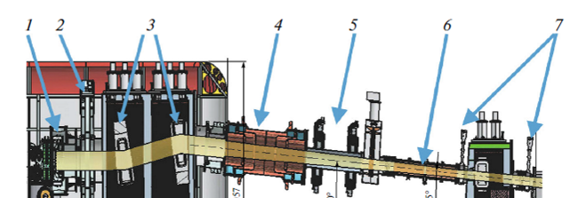
Figure 1. Schematic of the high-voltage neutral beam injector (side view): (1) ion source; (2) ion source gate valve; (3) LEBT bending magnets; (4) accelerating tube; (5) quadrupole magnets; (6) plasma neutralizer; (7) neutral’s path gate valves.

*) abstracts of this report in Russian

