Future OF OPEN MAGNETIC SYSTEMS FOR FUSION
Ivanov A.A., Bagryansky P.A., Beklemishev A.D., and Burdakov A.V.
Budker Institute of Nuclear Physics, Russian Academy of Sciences, Novosibirsk, Russia, A.A.Ivanov@inp.nsk.su
A short review of the current state of research of plasma confinement in open traps is presented. The leading role in this belongs to the Budker Institute of Nuclear Physics SB RAS. The main direction is the development of high-beta, high-density axisymmetric systems, useful for designing relatively compact reactors with high energy density. Experimental results of existing traps as well as new theoretical proposals [1] justify hopes for a breakthrough in the quality of confinement in the near future. Combination of high-beta with efficiency of the use of the magnetic field in axially symmetric linear traps allows discussion of tritium-less and even neutron-less fuels.
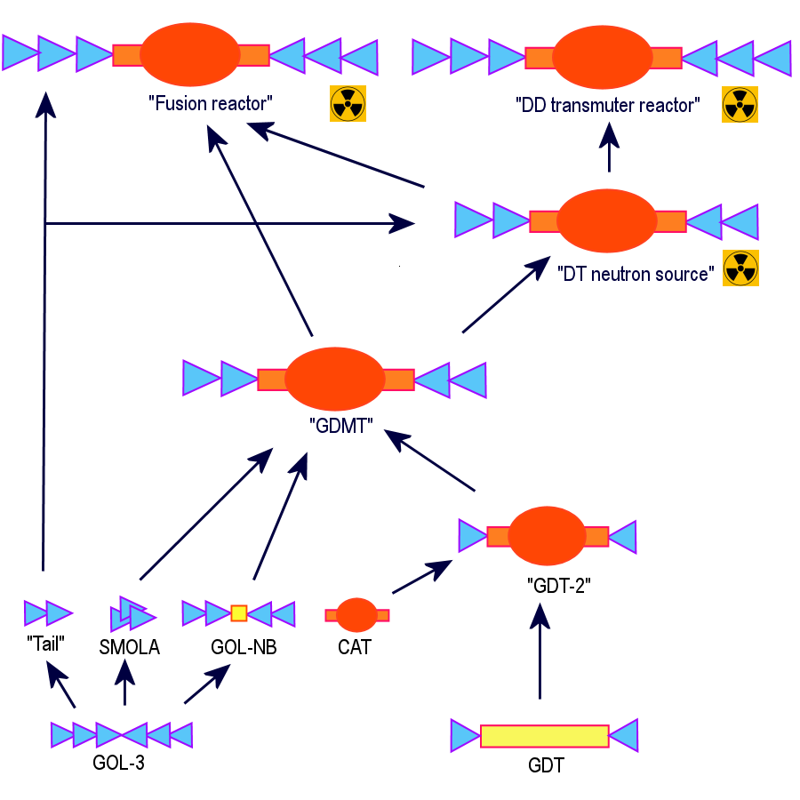
Roadmap to open-trap-based fusion systems of different type.
A this time experimental proof of new confinement principles is planned in BINP on relatively small devices «SMOLA» [2], «GOL-NB» and others. Main problems still outstanding that should be solved in the future are discussed.
References
- A.D. Beklemishev, Physics of Plasmas 23, 082506 (2016).
- V.V. Postupaev, A.V. Sudnikov, A.D. Beklemishev, I.A. Ivanov, Fusion Eng. and Design, 106, 29 (2016).

