Experimental study of toroidal correlations between density fluctuations along the magnetic field lines in T-10 tokamak and first results of numerical modeling
Buldakov M.A., Vershkov V.A., Isaev M.Yu., and Shelukhin D.A.
National Research Centre Kurchatov Institute, Moscow, Russia, m.a.buldakov@gmail.com
Correlation reflectometry experiments conducted in the T-10 tokamak showed [1, 2] that turbulence spectrum can be represented as a sum of the several types of density fluctuations, which have different radial, poloidal and toroidal correlational properties. Antenna arrays of T-10 tokamak shown in the figure enabled to conduct measurements of correlations of density fluctuations along the magnetic field line. Such experiments can give us additional information about physical properties of different types of fluctuations. Such measurements can also allow us to estimate current profile. In the cross-section D there are two antenna arrays at LFS and HFS. In the cross-section A separated toroidally by 90° from the cross-section D there are also two antenna arrays at LFS and HFS at poloidal angles 68,5° and 118,5°, correspondingly.

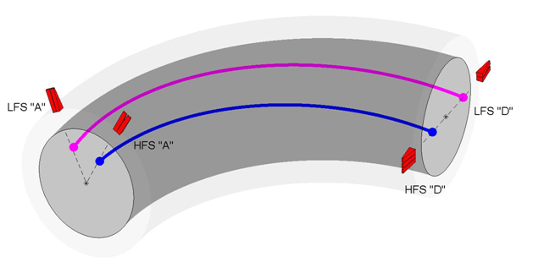
Figure. Schematics of T-10 antenna systems. Magnetic field lines at LFS and HFS are also shown
The antenna arrays installed at toroidally separated cross-sections enabled to conduct measurements of toroidal correlations at LFS and at HFS. Experiments were carried out for the two combinations of antennas showed in the figure. In the experiments plasma was probed by reflectometry at two ends of magnetic field line and correlations between two antenna signals were measured. The cutoff radius and corresponding q values were changed by variation of reflectometer frequency. The experiments showed that toroidal correlations are observed only for quasi-coherent (QC) fluctuations. Stochastic low frequency (SLF) and broad band (BB) fluctuations are not correlated at the distance of ¼ turn of the torus circumference. Numerical modeling of turbulence structure in T-10 tokamak was conducted in order to interpret experimental data and take into account non-locality of reflectometry. 2D stochastic model of turbulence was used. It was assumed that the magnitudes of density fluctuations are constant along magnetic field lines. Antenna signals at LFS and HFS were modeled by means of 2D full-wave electromagnetic code. It was shown that for the modeled signals toroidal correlations are high for QC in agreement with experiments. High toroidal correlations are also observed for BB fluctuations and it contradicts experimental data.
References
- Vershkov V.A. et al. Rev. Sci. Instrum.- 1999 – V. 70. - № 3. – P. 1700-1709.
- Vershkov V.A. et al. Nuclear Fusion. – 2005. – V. 45. - № 10. – P. S203-S226.

