Dynamics of GAM and preliminary measurements of turbulent particle flux in T-10 tokamak
¹Eliseev L.G., ¹Zenin V.N., ¹Lysenko S.E., ^{1,2}Melnikov A.V.
¹National Research Centre Kurchatov Institute, Moscow, Russia, Lysenko_SE@nrcki.ru
²Moscow Engineering Physics Institute, Moscow, Russia
Geodesic acoustic modes (GAMs) and the turbulent particle flux were studied in the T-10 tokamak in OH and ECRH discharges with B = 1.6–2.4 T, Ip = 0.15–0.3 MA, ‾ne = 0.6–5 × 10¹⁹ m^{–3}. At first time he broadband oscillations of electric potential and density with frequencies up to 250 kHz were measured by heavy ion beam probing (HIBP) in the plasma core. At the edge, ρ > 0.8, the dominated GAM peak with frequency ~14 kHz and the noticeable peak of quasicoherent oscillations in the frequency range 40–100 kHz were observed. HIBP measurements with multislit energy analyzer allow us to estimate the poloidal electric field E and the radial electrostatic turbulent particle flux driven by E × B drift. Preliminary experiments show that the GAM peak is seen on the spectrum of potential oscillations, Fig. 1 (a), but practically absent on the spectrum of E oscillations Fig. 1 (b) and on the frequency resolved particle flux. However, the flux is seen in the broadband range. These results agree both with the general theoretic conception that GAM is the high-frequency counterpart of zonal flows with symmetric poloidal structure of potential perturbation, and with previous measurements, where the poloidally symmetric mode with number m = 0 was observed [2].
The work was funded by Russian Scientific Foundation, project 14-22-00193.
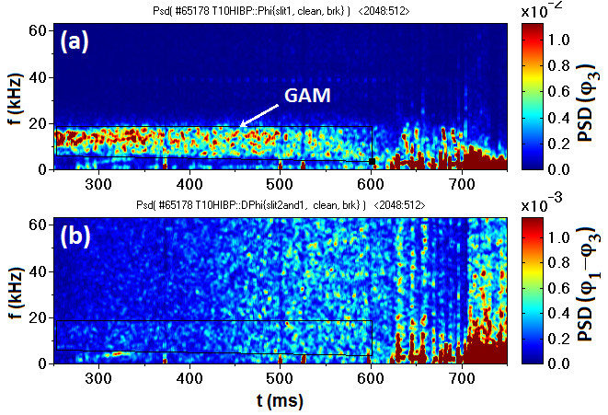

Fig. 1. GAMs are seen on the power spectral density (PSD) of potential oscillations,
measured by the central slit, φ₃, (a); but they are absent on PSD for difference of
potential oscillations measured by the central and edge slits (φ₁–φ₃), (b).
References
- Diamond P.H. et al., Plasma Phys. Control. Fusion. 2005, v. 47, p. R35.
- Zenin V.N. et al., Probl. Atom. Sci. Techn. Ser. Plasma Phys. 2014 (20), № 6. p. 269.

