studies of the angular distribution pf X-ray and gamma radiation in the ERG installation using the multichannel scintillation diagnostic complex
A.A. Rodionov^{1,2}, A.V. Agafonov¹, A.V. Oginov¹, K.V. Shpakov¹, I.S. Baidin^{1,3}
¹Lebedev Physical Institute, Russian Academy of Sciences, Moscow, Russia,
postmaster@lebedev.ru
²Moscow Institute of Physics and Technology, Dolgoprudnyi, Moscow oblast, Russia,
info@mipt.ru
³Moscow Engineering Physics Institute, Moscow, Russia, rector@mephi.ru
Studies of the atmospheric discharge at the ERG installation (LPI RAS) [1–2] have shown the need for the development of scintillation diagnostics. It is required to study low-background registration of short impulses of x-ray and gamma radiation (figure) with photon energies from tens of keV to a several MeV. It is important to provide the best time and amplitude resolution on the available types of photomultipliers and available hardware components [3] .
The paper presents the features of created "fast" scintillation detectors of radiation, based on the native PMT (the time resolution is ~5 ns), in assembly with use of various types of organic and inorganic scintillators. The special high-voltage power supply circuit, using the Zener voltage clamp circuit at the last stages of PMT amplification, was developed for providing demanded characteristics. Power dividers were optimized by techniques [4] to eliminate the instability of the PMT caused by a high time averaged load, and the linearity violation in pulse response. When designing buildings detectors are given special attention shielding from strong electromagnetic interference occurring at the time of discharge, for which the elements of the design were made of permalloy alloy 79HM.
The results of experimental studies of the anisotropy of short pulses of soft and hard X-ray, gamma and neutron radiation arising during the course of atmospheric discharge installation ERG (LPNU OYAFA LPI).
Statistical data collected during a consecutive series of experiments suggest the presence of radiation, their anisotropic character, and show the relationship of the observed phenomena with characteristics of current and voltage prepulse phase of atmospheric discharge.
This work was supported by Russian Science Foundation (project № 14-22-00273), RFBR (grant 17-08-01690, 17-08-01469) and grant Educational and Scientific Complex LPI (UNK).

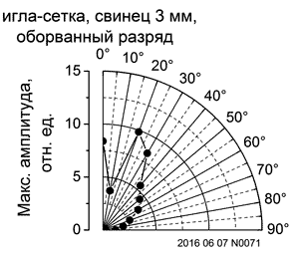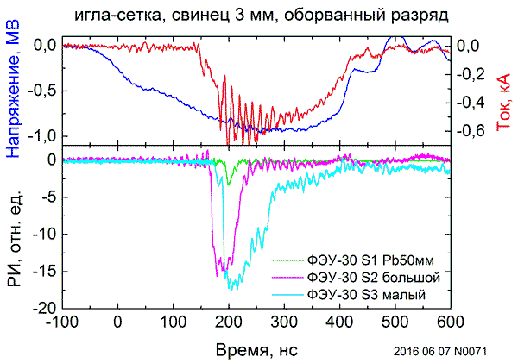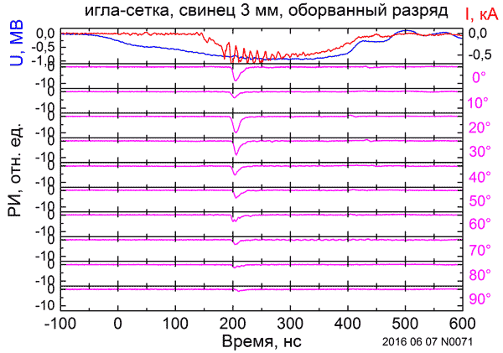

Figure. Pulse X-ray waveforms for each of the 10 detectors.
References
- A. V. Agafonov, A. V. Oginov, and K. V. Shpakov, Prebreakdown Phase in Atmospheric Discharges, Physics of Particles and Nuclei Letters, 2012, Vol. 9, No. 4–5, pp. 380–383.
- A. V. Agafonov, A. V. Bagulya, O. D. Dalkarov et al. Observation of Neutron Bursts Produced by Laboratory High-Voltage Atmospheric Discharge, Phys. Rev. Lett., 111, 115003 (2013).
- Baldakin B.O., Ronzhin A.P., Cisek Z., Preprint, PI3-7859, Dubna 1974.
- Basiladze S.G., Ivanov V.I., Preprint, 13-9172, Dubna, 1975.

