Production of NO_{x} AND Н₂О₂ by repetitive high-voltage discharge along the water – gas boundary
A.M. Anpilov, E.M. Barkhudarov, *Yu.N. Kozlov, I.A. Kossyi, M.I. Taktakishvili, and S.M. Temchin
Prokhorov General Physics Institute, RAS, Moscow, Russia anpilov56@gmail.com,
*Semenov Institute of Chemical Physics, RAS, Moscow, Russia, yunkoz@mail.ru
The plasma and the water, if in contact, give rise to radicals, such as OH, O, H₂O₂, NO_{x}, and the UV radiation. Owing to excellent oxidizing and disinfection properties, the plasma—water systems have a wider field of application (ecology, biology, medicine, plasma chemistry) and deserve closer study. In particular, the plasma may be generated by discharges propagating along the boundary of two media, by discharges in the liquid with bubbles and jets of gas, or if the liquid is used as electrodes in the discharge circuit [1, 2].
Below, we report experimental results on the NO_{x} and Н₂О₂ production with the use of repetitive high-voltage discharge propagating along the boundary of the water and gas (argon or air). The experimental device is a version of the original scheme [3] as shown in the figure 1.
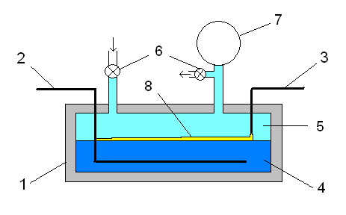
Power supply has the following parameters: voltage U ≤ 20 kV, pulse energy w ≤ 1.6 J, pulse repetition frequency f ≤ 100 Hz, and pulse duration τ = 3 - 4 μs. The length of the discharge channel was varied in the range L=4 – 14 cm. The plasma in the channel has the following parameters: electron temperature Т_{е} = 1-1.5 eV, electron density N_{e} = (2 - 3)·10¹⁷cm⁻³, gas temperature T_{g} = (4 - 5)·10³ K; the channel diameter is equal to 0.1 mm [3].
Figure 1. This is experimental device.
1 - Acrylic plastic cell (200 ml); 2, 3 - electrodes; 4 - water (100 ml); 5 - gas (Ar or air); 6 - gas inlet and outlet; 7 - manometer; 8 - slipping surface discharge.

Methods to determine concentrations of the radicals of interest to us are as follows:
- hydrogen peroxide (Н₂О₂), obtained after argon was blown through the reactor, was determined by the titanium method;
- nitrogen dioxide (NO₂), after air was blown through the reactor, was determined from increased water conductivity;
- the total concentration of nitrogen oxides (NO_{x}=NO+NO₂) was determined with the help of an indicator test tube.
The experimental results can be summarized as follows:
- the concentrations of nitrogen oxides are in the ratio NO:NO₂=100:5;
- the quantity of Н₂О₂ и NO_{x} increases directly with L;
- the energy cost of production in the discharge channel of length L=11 cm is estimated as
H₂O₂ – 600eV/molec, NO_{x} – 500eV/molec.
The above experimental results may be useful in applications, as well as, in investigations of atmospheric discharges along the surface of waters.
References
- B.R.Locke at all, Ind. Chem. Res. 2006, 45, p.882-905
- P.Bruggeman, Ch. Leys, J. Phys.D: Appl. Phys. 42 (2009) 053001 p.28
- A.M.Anpilov, E.M.Barkhudarov, V.A.Kop’ev, I.A.Kossyi, 28 ICPIG, July 15-20, 2007, Prague, Czech Republic.

