LONG-LIVED GLOWING FFORMATIONS CREATED WITH THE CAPILLARY DISCHARGE
^{1,2}V.L. Bychkov, ¹A.S. Osokin, ¹I.G. Stepanov, ¹A.I. Stepanov, and ¹V.A. Chernikov
¹Physical Faculty, Lomonosov MSU, Leninskye gory, 119991 Moscow, Russia, bychvl@gmauil.com
²Moscow Radiotechnical Institute RAS, Warsawskoe Shosses, 132, 117519 Moscow, Russia,
bychvl@gmauil.com
Questions of origination and nature of long-lived glowing objects (LGO) attract attention in connection with investigations of energy transportation for long distances and nature of natural glowing formations like ball lightning, St.Elms and Hessdallen fires, etc. Because of this we continued investigations on formation of LGO with a help of the capillary plasma generators. For creation of the capillary discharge we used capillaries made of organic glass, or a mixture of wax with fine disperse wooden particles of 1,5-2 mm diameter. The upper electrode was made of tin or steel. Starting of the plasma generator and registrating oscilloscope was realized by synchropulses coming from the pulse generator Г5-15.
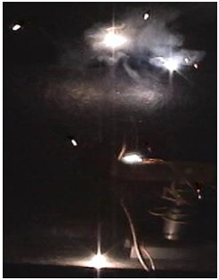
For clarification of LGO elimination type investigations were made with fusible material-tin. For this purpose the wire of tin of 1.5 mm in diameter was located over the capillary. Then it was lowered directly into the capillary hole. At the plasma jet impact to tin the lower part of the wire (about of 0.3-0.5 mm) was sharply heated , melted and flew out together with the plasma jet from the capillary in a form of glowing formations (see Fig.1). This objects fell down on sheets of paper and left different traces on them. In case of the explosion a star-like image was left on the paper surface (see Fig.2a). In the opposite case the LGO jumping over paper left traces in a form of a drop (see Fig.2b). The lifetime of the objects reached 1- 1.5 s.
Fig. 2 a Fig. 2 b

Fig. 1. Glowing Formations.

The type of the LGO elimination allows to make a conclusion about different modes of energy input into the metal at plasma- metal interaction: with melting of the metal and creation of a liquid; and with creation of a gas inside the cover. The last circumstance allows appearance of a sound at LGO destruction.
The work was partially supported by the grant of RFBR 12-07-00654.

